Why did Rome Fall?
The phrase "the Fall of Rome" suggests that some cataclysmic event ended the Roman Empire which had stretched from the British Isles to Egypt and Iraq. But at the end, there was no straining at the gates, no barbarian horde that dispatched the Roman Empire in one fell swoop.
Instead, the Roman Empire fell slowly as a result of challenges from within and without, and changing over the course of hundreds of years until its form was unrecognizable. Because of the long process, different historians have placed an end date at many different points on a continuum. Perhaps the Fall of Rome is best understood as a compilation of various maladies that altered a large swath of human habitation over many hundreds of years.

When Did Rome Fall?
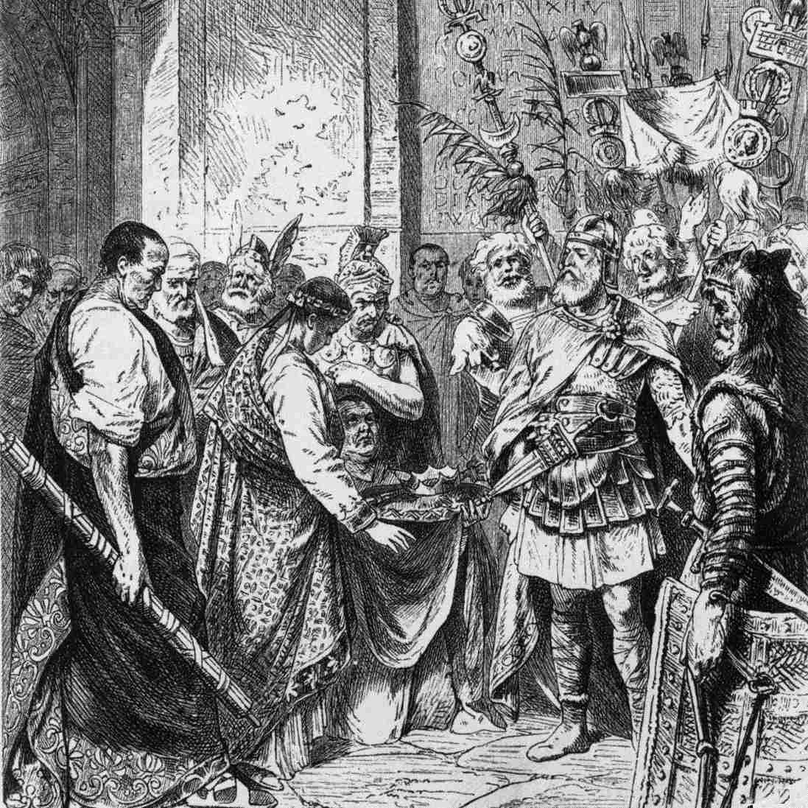
19th-century illustration of Romulus Augustulus resigning the Roman crown to Odoacer; from an unknown source. Public Domain/Wikimedia
In his masterwork, The Decline and Fall of the Roman Empire, historian Edward Gibbon selected 476 CE, a date most often mentioned by historians. That date was when Odoacer, the Germanic king of the Torcilingi, deposed Romulus Augustulus, the last Roman emperor to rule the western part of the Roman Empire. The eastern half became the Byzantine Empire, with its capital at Constantinople (modern Istanbul).
But the city of Rome continued to exist. Some see the rise of Christianity as putting an end to the Romans; those who disagree with that find the rise of Islam a more fitting bookend to the end of the empire—but that would put the Fall of Rome at Constantinople in 1453! In the end, the arrival of Odoacer was but one of many barbarian incursions into the empire. Certainly, the people who lived through the takeover would probably be surprised by the importance we place on determining an exact event and time.

How Did Rome Fall?
Just as the Fall of Rome was not caused by a single event, the way Rome fell was also complex. In fact, during the period of imperial decline, the empire actually expanded. That influx of conquered peoples and lands changed the structure of the Roman government. Emperors moved the capital away from the city of Rome, too. The schism of east and west created not just an eastern capital first in Nicomedia and then Constantinople, but also a move in the west from Rome to Milan.
Rome started out as a small, hilly settlement by the Tiber River in the middle of the Italian boot, surrounded by more powerful neighbors. By the time Rome became an empire, the territory covered by the term "Rome" looked completely different. It reached its greatest extent in the second century CE. Some of the arguments about the Fall of Rome focus on the geographic diversity and the territorial expanse that Roman emperors and their legions had to control.

Why Did Rome Fall?
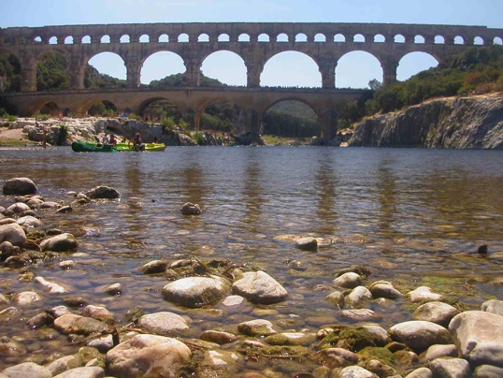
Pont du Gard, Roman Aqueduct, France. Karoly Lorentey
This is easily the most argued question about the fall of Rome. The Roman Empire lasted over a thousand years and represented a sophisticated and adaptive civilization. Some historians maintain that it was the split into an eastern and western empire governed by separate emperors caused Rome to fall. Most classicists believe that a combination of factors including Christianity, decadence, the metal lead in the water supply, monetary trouble, and military problems caused the Fall of Rome. Imperial incompetence and chance could be added to the list. And still, others question the assumption behind the question and maintain that the Roman empire didn't fall so much as adapt to changing circumstances.

Christianity
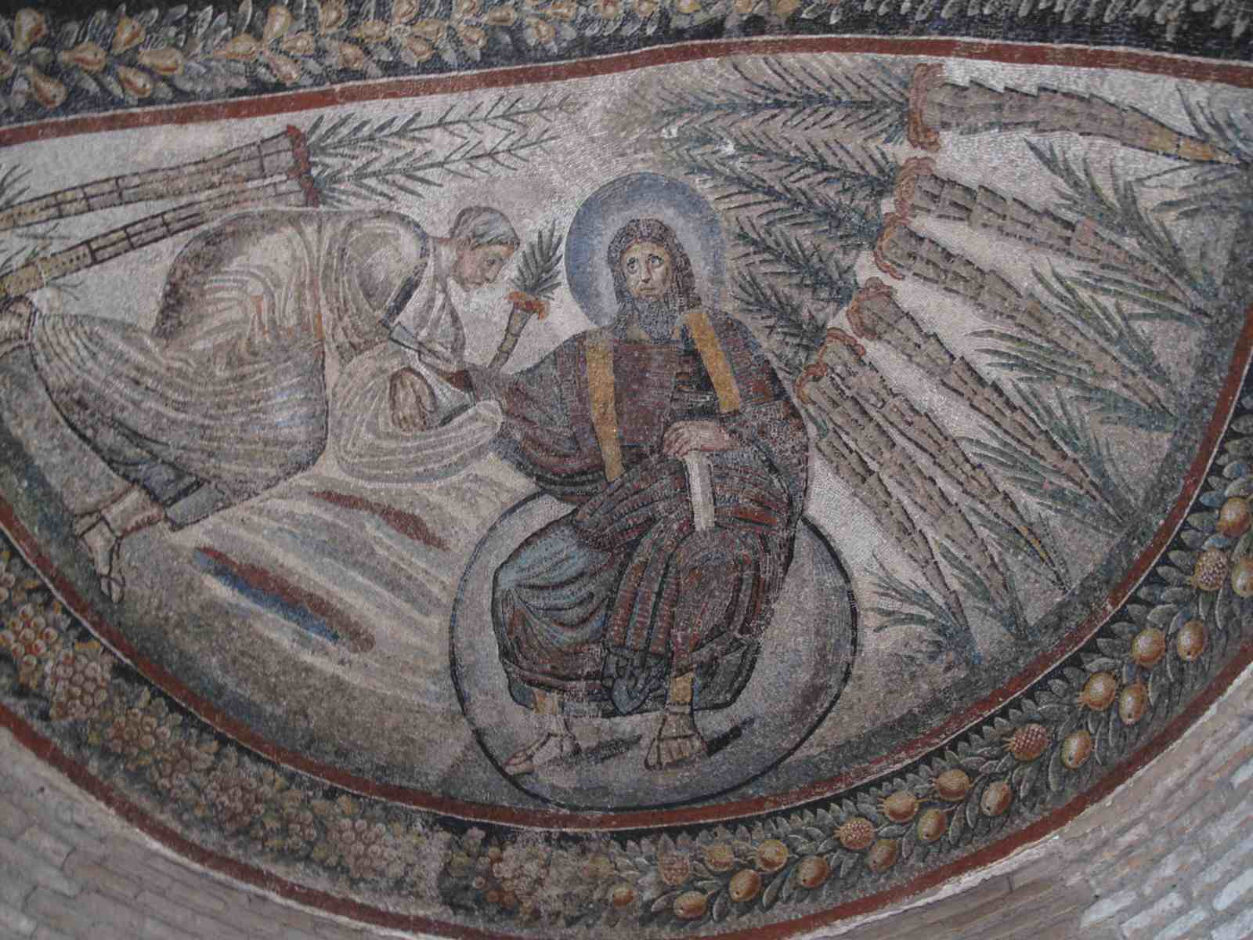
4th-century mosaic in the vault of a mausoleum built under Constantine the Great for his daughter Constantina (Costanza), who died in 354 AD. R Rumora (2012) Institute for the Study of the Ancient World
When the Roman Empire started, there was no such religion as Christianity. In the 1st century CE, Herod executed their founder Jesus for treasonous behavior. It took his followers a few centuries to gain enough clout to be able to win over imperial support. This began in the early 4th century with Emperor Constantine, who was actively involved in Christian policy-making.
When Constantine established a state-level religious tolerance in the Roman Empire, he took on the title of Pontiff. Although he was not necessarily a Christian himself (he wasn't baptized until he was on his deathbed), he gave Christians privileges and oversaw major Christian religious disputes. He may not have understood how the pagan cults, including those of the emperors, were at odds with the new monotheistic religion, but they were, and in time the old Roman religions lost out.
Over time, Christian church leaders became increasingly influential, eroding the emperors' powers. For example, when Bishop Ambrose (340–397 CE) threatened to withhold the sacraments, Emperor Theodosius did the penance the Bishop assigned him. Emperor Theodosius made Christianity the official religion in 390 CE. Since Roman civic and religious life were deeply connected—priestesses controlled the fortune of Rome, prophetic books told leaders what they needed to win wars, and emperors were deified—Christian religious beliefs and allegiances conflicted with the working of empire.

Barbarians and Vandals
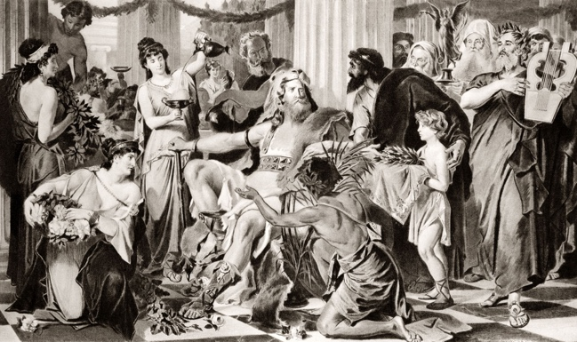
395 BC Visigoth King Alaric. Getty Images/Charles Phelps Cushing/ClassicStock
The barbarians, which is a term that covers a varied and changing group of outsiders, were embraced by Rome, who used them as suppliers of tax revenue and bodies for the military, even promoting them to positions of power. But Rome also lost territory and revenue to them, especially in northern Africa, which Rome lost to the Vandals at the time St. Augustine, in the early 5th century CE.
At the same time the Vandals took over the Roman territory in Africa, Rome lost Spain to the Sueves, Alans, and Visigoths. The loss of Spain meant Rome lost revenue along with the territory and administrative control, a perfect example of the interconnected causes leading to Rome's fall. That revenue was needed to support Rome's army and Rome needed its army to keep what territory it still maintained.

Decadence and Decay of Rome's Control
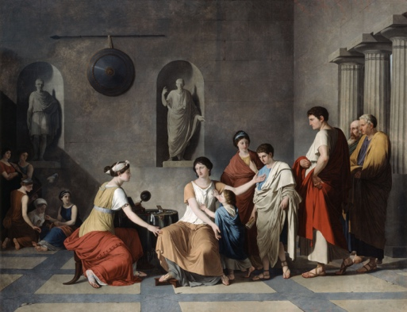
'The Mother of the Gracchi', c1780. Artist: Joseph Benoit Suvee. Print Collector/Getty Images / Getty Images
There is no doubt that decay—the loss of Roman control over the military and populace—affected the ability of the Roman Empire to keep its borders intact. Early issues included the crises of the Republic in the first century BCE under the emperors Sulla and Marius, as well as that of the Gracchi brothers in the second century CE. But by the fourth century, the Roman Empire had simply become too big to control easily.
The decay of the army, according to the 5th-century Roman historian Vegetius, came from within the army itself. The army grew weak from the lack of wars and stopped wearing their protective armor. This made them vulnerable to enemy weapons and provided a temptation to flee from battle. Security may have led to the cessation of the rigorous drills. Vegetius says the leaders became incompetent and rewards were unfairly distributed.
In addition, as time went on, Roman citizens including soldiers and their families living outside of Italy, identified with Rome less and less compared to their Italian counterparts. They preferred to live as natives, even if this meant poverty, which, in turn, meant they turned to those who could help—Germans, brigands, Christians, and Vandals.

Lead Poisoning
Some scholars have suggested that the Romans suffered from lead poisoning. There was lead in Roman drinking water, leached in from water pipes used in the vast Roman water control system; lead glazes on containers that came in contact with food and beverages; and food preparation techniques that could have contributed to heavy metal poisoning. The lead was also used in cosmetics, even though it was also known in Roman times as a deadly poison, and used in contraception.

Economics
Economic factors are also often cited as a major cause of the fall of Rome. Some of the major factors, like inflation, over-taxation, and feudalism are discussed elsewhere. Other lesser economic issues included the wholesale hoarding of bullion by Roman citizens, the widespread looting of the Roman treasury by barbarians, and a massive trade deficit with the eastern regions of the empire. Together these issues combined to escalate financial stress during the empire's last days.

