Document Based Question – 2020
Question 1 is based on the accompanying documents. The documents have been edited for the purpose of this exercise.
QUESTION 1: Evaluate the extent of change in ideas about slavery from 1763 to 1863.
Document 1
Source: Public notice, Virginia, 1769.

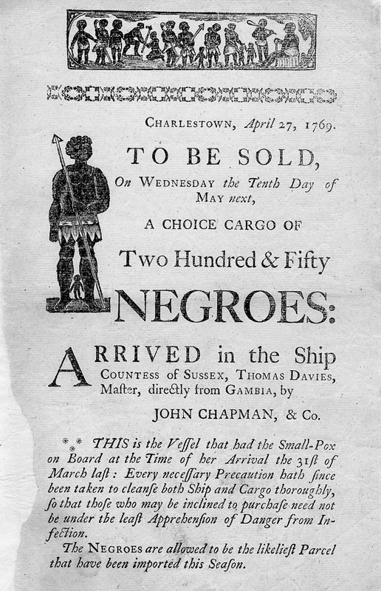

Document 2
Source: Account by John Rolfe, cited in Arber, Edward, ed. Travels and Works of Captain John Smith: President of Virginia, and Admiral of New England, 1580-1631.
For to begin with the yeere of our Lord, 1619. On the eighteenth of Aprill … we thought our selves now fully satisfied for our long toile and labours, and as happy men as any in the world. Notwithstanding, we … may well tend foure akers of Corne, and 1000. plants of Tobacco; and where they say an aker will yeeld but three or foure barrels, we have ordinarily foure or fiue, but of new ground six, seven, and eight, and a barrell of Pease and Beanes, which we esteeme as good as two of Corne, which is after thirty or forty bushels an aker, so that one man may provide Corne for five; and apparell for two by the profit of his Tobacco. About the last of August [1619] came in a dutch man of warre that sold us twenty Negars: and King of Patawomeck, came to James towne, to desire two ships to come trade in his River, for a more plentifull yeere of Corne had not beene in a long time … I pray God it be well observed, and then we may truly say in Virginia, we are the most happy people in the world. By me John Rolfe.

Document 3
The Federalist Papers: No. 54. The Apportionment of Members Among the States. Authored by J. Madison or A. Hamilton. February 12, 1788.
It is not contended that the number of people in each State ought not to be the standard for regulating the proportion of those who are to represent the people of each State … All this is admitted, … but does it follow, from an admission of numbers for the measure of representation, or of slaves combined with free citizens as a ratio of taxation, that slaves ought to be included in the numerical rule of representation? Slaves are considered as property, not as persons. They ought therefore to be comprehended in estimates of taxation which are founded on property, and to be excluded from representation which is regulated by a census of persons … I shall be equally candid in stating the reasoning which may be offered on the opposite side. "We subscribe to the doctrine,'' might one of our Southern brethren observe, "that representation relates more immediately to persons, and taxation more immediately to property, and we join in the application of this distinction to the case of our slaves. But we must deny the fact, that slaves are considered merely as property, and in no respect whatever as persons. The true state of the case is, that they partake of both these qualities: being considered by our laws, in some respects, as persons, and in other respects as property.
The federal Constitution, therefore, decides with great propriety on the case of our slaves, when it views them in the mixed character of persons and of property. This is in fact their true character. … Let the case of the slaves be considered, as it is in truth, a peculiar one. Let the compromising expedient of the Constitution be mutually adopted, which regards them as inhabitants, but as debased by servitude below the equal level of free inhabitants, which regards the SLAVE as divested of two fifths of the MAN.

Document 4
Source: Henry Clay, Speech in the U.S. Senate February 14, 1850.

It is totally unnecessary for the gentleman to remind me of my coming from a slaveholding state. I know whence I came, and I know my duty, and I am ready to submit to any responsibility which belongs to me as a senator from a slaveholding state. I have heard something said on this and a former occasion about allegiance to the South. I know no South, no North, no East, no West, to which I owe any allegiance. I owe allegiance to two sovereignty, and only two: one is the sovereignty of this Union, and the other is the sovereignty of the state of Kentucky. My allegiance is to this Union and to my state; but if gentlemen suppose they can exact from me an acknowledgement of allegiance to any ideal or future contemplated confederacy of the South, I here declare that I owe no allegiance to it; nor will I, for one, come under any such allegiance if I can avoid it.

Document 5
Source: Abraham Lincoln to Congress, March 1862.

I recommend the adoption of a joint resolution by your honorable bodies, which shall be substantially as follows: Resolved, that the United States ought to cooperate with any state which may adopt gradual abolishment of slavery, giving to such state pecuniary aid, to be used by such state, in its discretion, to compensate for the inconveniences, public and private, produced by such change of system … the Federal government would find its highest interest in such a measure as one of the most efficient means of self-preservation.

