Name:
Period 8 (1945 – 1980) Review Sheet

Welcome to Period 8! This period is the second largest period of the APUSH curriculum, at 15%.
C
H
E
C
K

I
T

O
U
T
!

Potential Short Answer Questions/Essay Topics Include:
- Comparing the Civil Rights Movement of the 1950s and 1960s with a previous period (Reconstruction or early 1900s – Niagara Movement)
- Analyzing the tactics used, and successes of the Civil Rights Movement
- US foreign policy during the Cold War – Containment, Korean War, Vietnam War, etc.
- Comparing the Great Society with the New Deal

Why were these years chosen for this period?
1945 marked the end of World War II and the beginning of the Cold War. The Cold War led to a new US foreign policy and involvement in two wars – Korea and Vietnam. During the 1950s and 1960s, the Civil Rights Movement achieved many milestones. The 1970s saw an increase in the American public distrust in the federal government, particularly under Richard Nixon. Finally, 1980 ushered in a Conservative Movement with the election of Ronal Reagan.

Key vocabulary terms to know for this time period:
Check the following terms out on Quizlet HERE

Containment: Coined by George Kennan; urged the US to keep communism from spreading (Contain communism)
Korean War: Example of Containment; US sided with South Korea against communist North Korea; some minor domestic opposition to the war
Military-Industrial Complex: Eisenhower warned of a drastic military buildup in his farewell address
Baby Boom: Post WWII drastic increase in births in the US (1946 - 1964); led to future issues with Social Security
Suburbanization: More and more Americans moved to suburbs after WWII (cars, Interstate Highway System, Levittown)
Civil Rights Activists: Used various techniques (sit-ins, legal challenges, etc.); post-1965, debates emerged over the proper role of activists
Brown v. Board of Education: 1954 Supreme Court Case that ruled separate facilities based on race inherently unequal. Reversed Plessy v. Ferguson
Sunbelt: VA to FL, extending to CA; saw a large population increase after WWII and rise of key industries
Great Society: LBJ's platform; increased the size and involvement of the government in society. Extension of New Deal programs and Civil Rights (24th amendment, Civil Rights Act of 1964.)
Immigration Laws of 1965: Reversed discriminatory quotas acts from the 1920s; favored immigrants from Latin America and Asia
Vietnam War: US aided the South (non-communist); led to sizeable, passionate, and sometimes violent protests, especially as the war went on
Counterculture: "Hippies" - protested Vietnam War; rejected many ideas of their parents' generation; used marijuana; helped start a sexual revolution
Détente: Easing of Cold War tensions between the US and Soviet Union (Examples include: SALT I and Salt II)
Environmental Problems: Brought to the attention of the public by Rachel Carson and Silent Spring; helped lead to the creation of the EPA and Clean Air Act
Hold Up!

Watch THIS video on Period 8 before you proceed. (10 minutes)

1. What is the “sunbelt?” Why did this area see an increase in population after WWII?

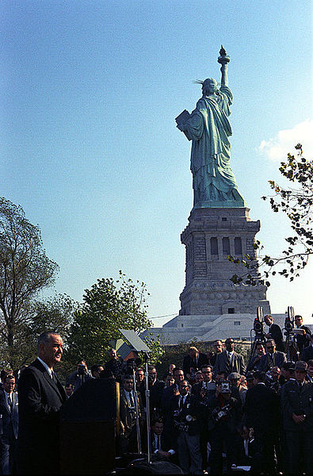
2. What was the image of a nuclear family in the 1950s?

3. What did the Immigration Act of 1965 reverse?

4. What was the message of Betty Friedan’s The Feminine Mystique?

5. Describe the rights the following groups hoped to achieve/did achieve:
- Latinos:
- Native Americans:
- Women:
- Gay and lesbian activists:

6. What was the message and impact of Rachel Carson’s Silent Spring?

7. What was the goal of Lyndon Johnson’s Great Society? Name three elements of LBJ’s Great Society.

8. How did the Presidency of Richard Nixon lead to a decrease of public trust in government?

The following questions are based on the beginning of the Cold War:

9. What is Containment?

10. What was the purpose of the Truman Doctrine? How is this an example of Containment?

11. What was the purpose of the Marshall Plan? How is this an example of Containment?

12. Please describe the Cuban Missile Crisis.

The following questions are based on the Presidency of Harry Truman:
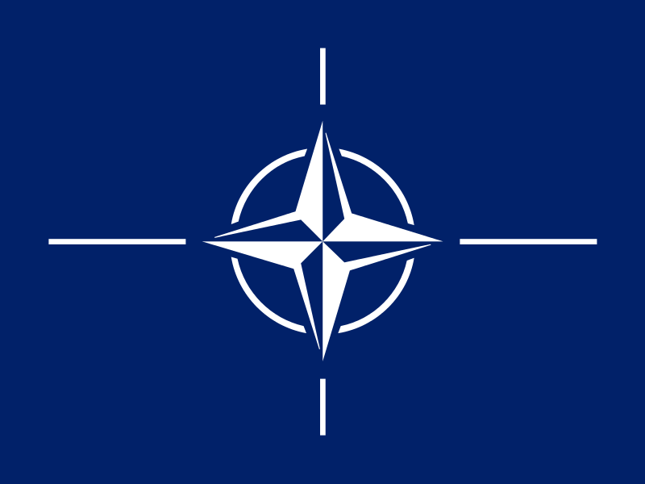
13. What was The “Fair Deal?” Was it successful?

14. Why did the US establish the North Atlantic Treaty Organization (NATO)?

15. How would George Washington view NATO based on his advice in his Farewell Address?

16. When China became a communist nation, how did that impact Truman?

17. What did Executive Order 9981 do?

The following questions are based on the Second Red Scare:

18. What were two reasons for the Second Red Scare?

19. What was the purpose of HUAC?

20. How is the “Hollywood Ten” an example of fear of communism?

21. How could Joseph McCarthy be seen as a demagogue? How did he contribute to the Second Red Scare?

22. What happens to individual rights and liberties during times of crisis?

The following questions are based on the Korean War:
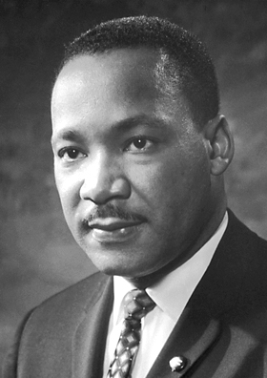
23. How could the Korean War be seen as an example of Containment?

24. Why did President Truman fire General MacArthur?

25. What was the boundary between North and South Korea at the end of the war?

The following questions are based on the Civil Rights Movement of the 1950s and 1960s:

26. What did the Supreme Court rule in Brown v. Board of Education? Which previous court case did it reverse?

27. What was the message of the Southern Manifesto?

28. Why did Eisenhower send troops to Little Rock, Arkansas in 1957? What is this event more commonly known as?

29. How did the following contribute to Civil Rights? (Please make sure you know them in detail. These are so significant in American history.)
- Civil Rights Act of 1964:

- Voting Rights Act of 1965:

- 24th Amendment:

The following questions are based on the Vietnam War:

30. What is the “Domino Theory?”

31. What the impact of the Gulf of Tonkin Resolution?

32. Why did protests increase as the war continued?

33. What is Vietnamization?

34. What did the War Powers Act do?

35. What was the impact of the war on the economy?

Document Analysis

“DOC 1: Greece is not a rich country. Lack of sufficient natural resources has always forced the Greek people to work hard to make both ends meet. Since 1940, this industrious and peace loving country has suffered invasion, four years of cruel enemy occupation, and bitter internal strife.
The very existence of the Greek state is today threatened by the terrorist activities of several thousand armed men, led by Communists, who defy the government's authority at a number of points, particularly along the northern boundaries…………
Meanwhile, the Greek Government is unable to cope with the situation. The Greek army is small and poorly equipped. It needs supplies and equipment if it is to restore the authority of the government throughout Greek territory. Greece must have assistance if it is to become a self-supporting and self-respecting democracy.
The United States must supply that assistance. We have already extended to Greece certain types of relief and economic aid but these are inadequate.”
- Truman Doctrine
(Check out THIS video for a quick review.)

Document Analysis Questions

1. Why does Greece struggle economically according to the author?

2. Who is threatening the Greek government?

3. Please explain how each of the following people would view this request for aid.
- George Washington:

- Henry Cabot Lodge:

- George Kennan:

- Charles Lindbergh:

4. How could this be seen as a turning point in US foreign policy?
HAPPY Analysis

1. What is the Historical Circumstance of this document?

2. Who is the Audience of this document?

3. What is the Point of View of the document?

4. What is the Purpose of this document?

DOC 2: "The unwarranted decision of the Supreme Court in the public school cases is now bearing the fruit always produced when men substitute naked power for established law."
"The original Constitution does not mention education. Neither does the 14th Amendment nor any other amendment. The debates preceding the submission of the 14th Amendment clearly show that there was no intent that it should affect the system of education maintained by the States."
"This unwarranted exercise of power by the Court, contrary to the Constitution, is creating chaos and confusion in the States principally affected. It is destroying the amicable relations between the white and Negro races that have been created through 90 years of patient effort by the good people of both races. It has planted hatred and suspicion where there has been heretofore friendship and understanding."
- Southern Manifesto, 1956
(Check out THIS video for a quick review.)

HAPPY Analysis

1. What is the Historical Circumstance of this document?

2. Who is the Audience of this document?

3. What is the Point of View of the document?

4. What is the Purpose of this document?

DOC 3: “It is important that the reasons for my action be understood by all our citizens. As you know, the Supreme Court of the United States has decided that separate public educational facilities for the races are inherently unequal and therefore compulsory school segregation laws are unconstitutional.

Our personal opinions about the decision have no bearing on the matter of enforcement; the responsibility and authority of the Supreme Court to interpret the Constitution are very clear. Local Federal Courts were instructed by the Supreme Court to issue such orders and decrees as might be necessary to achieve admission to public schools without regard to race—and with all deliberate speed.

During the past several years, many communities in our Southern States have instituted public school plans for gradual progress in the enrollment and attendance of school children of all races in order to bring themselves into compliance with the law of the land.
They thus demonstrated to the world that we are a nation in which laws, not men, are supreme.”
- President Eisenhower’s Address About Little Rock High School, 1957
(Check out THIS video for a quick review.)

HAPPY Analysis

1. What is the Historical Circumstance of this document?Name two events that happened prior to this event and two key events that happened after this eveng.

2. Who is the Audience of this document?

3. What is the Point of View of the document?

4. What is the Purpose of this document?

DOC 4: “YOU express a great deal of anxiety over our willingness to break laws. This is certainly a legitimate concern. Since we so diligently urge people to obey the Supreme Court's decision of 1954 outlawing segregation in the public schools, it is rather strange and paradoxical to find us consciously breaking laws. One may well ask, "How can you advocate breaking some laws and obeying others?" The answer is found in the fact that there are two types of laws: there are just laws, and there are unjust laws. I would agree with St. Augustine that "An unjust law is no law at all."
Martin Luther King, Jr. – Letter From A Birmingham Jail
(Check out THIS video for a quick review.)

Happy Analysis

1. What is the Historical Circumstance of this document?

2. Who is the Audience of this document?

3. What is the Point of View of the document?

4. What is the Purpose of this document?

DOC 5: “To promote the maintenance of international peace and security in Southeast Asia.
Whereas naval units of the Communist regime in Vietnam, in violation of the principles of the Charter of the United Nations and of international law, have deliberately and repeatedly attacked United Stated naval vessels lawfully present in international waters, and have thereby created a serious threat to international peace…..
Resolved by the Senate and House of Representatives of the United States of America in Congress assembled, That the Congress approves and supports the determination of the President, as Commander in Chief, to take all necessary measures to repel any armed attack against the forces of the United States and to prevent further aggression.”
-- 1964, Gulf of Tonkin Resolution
(Check out THIS video for a quick review.)

Document Questions

1. What is the impact of this document?

2. How does it affect checks and balances?

3. What was passed to limit/overturn this act?

HAPPY Analysis

1. What is the Historical Circumstance of this document?

2. Who is the Audience of this document?

3. What is the Point of View of the document?

4. What is the Purpose of this document?

DOC 6:; “I am acutely aware that you have not elected me as your President by your ballots, and so I ask you to confirm me as your President with your prayers. And I hope that such prayers will also be the first of many... If you have not chosen me by secret ballot, neither have I gained office by any secret promises. I have not campaigned either for the Presidency or the Vice Presidency. I have not subscribed to any partisan platform. I am indebted to no man, and only to one woman—my dear wife, Betty—as I begin this very difficult job... My fellow Americans, our long national nightmare is over... Our Constitution works; our great Republic is a government of laws and not of men. Here the people rule. But there is a higher Power, by whatever name we honor Him, who ordains not only righteousness but love, not only justice but mercy.”
- President Gerald Ford’s Inaugural Address, 1974
(Check out THIS video for a quick review.)

HAPPY Analysis

1. What is the Historical Circumstance of this document?

2. Who is the Audience of this document?

3. What is the Point of View of the document?

4. What is the Purpose of this document?

