Name:
Period 6 (1865 – 1898) Review Sheet
C
H
E
C
K

I
T

O
U
T
!

Potential Short Answer Questions/Essay Topics Include:
- Comparing and Contrasting different labor unions (Knights of Labor and AFL)
- Comparing and Contrasting “”Old” Immigration with “New” Immigration
- US relations with Native Americans in the late 19th century
- Reasons for the development of the Populist Party

Why were these years chosen for this period?
1865 marked the end of the Civil War. Americans began to expand westward at increasingly high rates. The federal government provided incentives to railroad companies to build transcontinental railroads. Native Americans, farmers, and the industrial work force make up a large portion of this time period. 1898 marked the beginning of the Spanish-American War – the US burst onto the international scene.

Key vocabulary terms to know for this time period:

Check the following terms out on Quizlet HERE

Gilded Age: Coined term by Mark Twain; period from 1870s - 1890s, businesses grew at a rapid rate and many problems lied below perceived prosperity
Social Darwinism: Charles Darwin's ideas applied to humans, "survival of the fittest." Used by wealthy to justify their position in life
Labor Unions: Knights of Labor - skilled and unskilled; AFL - skilled labor only; sought to improve working conditions and increase pay
“New South”: Idea that the south should industrialize after the Civil War. Despite calls for industrialization, sharecropping and tenant farming persisted in the South
Sharecropping: Persisted in the South (especially for African Americans.) They had to give a share of their crops to plantation owners. Way for southerners to get around the 13th amendment.
Mechanized Agriculture: Using machines in farming to increase farm production; displaced many farmers; farmers created organizations to resist corporate power (Grange)
People’s (Populist) Party: Created in response to the growth of corporate power; called for political reform (election of senators, secret ballot) and increased government involvement in economy
Political Machines: Appealed to immigrants and urban poor; provided services in exchange for support. Think Boss Tweed and Tammany Hall
Settlement Houses: Helped immigrants adjust to American life. Focused on providing education and other skills for women, immigrants, and children
Decimation of the buffalo: Buffalo almost became extinct due to westward expansion and over hunting of buffalo (buffalo hide); impacted Native Americans
Plessy v. Ferguson: Established the doctrine of "separate but equal." Upheld Jim Crow laws in the South, led to increased discrimination against African Americans; later overturned by Brown v. Board.
Social Gospel: Protestant Church Movement that sought to improve the conditions of cities
Assimilation of Native Americans: Process of making Natives "American"; Dawes Act - assimilated through cutting hair, changing tribal identities, providing individual land plots
Hold Up!

Watch THIS video on Period 6 before you proceed. (10 minutes)

1. Why did businesses consolidate into monopolies, pools, trusts, and interlocking directorates?

2. What is Social Darwinism? How did the wealthy use this to justify their place in society?

3. What is the purpose of Unions? In conflicts between labor and management, whose side did the federal government usually take?

4. Complete the following chart based on the Knights of Labor and American Federation of Labor.
 | Knights of Labor | American Federation of Labor
Leader
Membership type (skilled, unskilled, makeup, etc.)

5. What is sharecropping? How did this affect African Americans?

6. What is the “New South?”

7. Why did many farmers migrate to cities?

8. What was the purpose of farmer organizations such as the Grange?

9. What does laissez-faire mean?

10. How did the Election of 1896 demonstrate tensions between farmers and the wealthy?

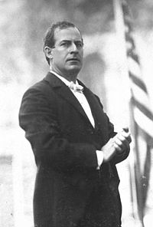
11. What were three goals of the Populist Party? Were they successful in achieving these goals?

12. What groups made up “New” Immigrants?

13. How did they differ from “Old” Immigrants?
 | “Old” Immigrants | “New” Immigrants
Countries of origin
Places they settled
When they came here
Reasons for coming here
Responses to immigration
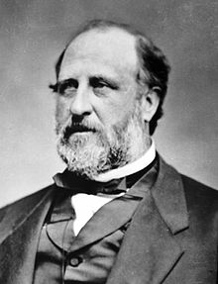
14. What are Political Machines? Why did they appeal to immigrants?

15. How did Jane Addams help immigrants adapt to U.S. society through her Hull House?

16. How did the following seek to improve life for African Americans?
- Booker T. Washington:
- Ida B. Wells:

17. What was the impact of the Supreme Court decision, Plessy v. Ferguson?

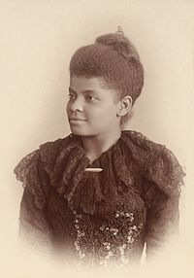
18. What was the Social Gospel?

The following questions are based on Native Americans in the late 19th Century.

19. Explain two conflicts between the American government and Natives after the Civil War.

20. What is assimilation? How did the Dawes Act impact Native Americans?

21. How did the Ghost Dance lead to conflicts between Natives and the federal government?

Document Analysis

DOC 1: To every one applying to rent land upon shares, the following conditions must be read, and agreed to….. The croppers are to have half of the cotton, corn, and fodder (and peas and pumpkins and potatoes if any are planted) if the following conditions are complied with, but-if not-they are to have only two-fifths (2/5). Nothing can be sold from their (sharecroppers’) crops until my rent is all paid, and all amounts they owe me are paid in full. All must work under my direction……..Work of every description, particularly the work on fences and ditches, to be done to my satisfaction, and must be done over until I am satisfied that it is done as it should be.
- Sharecropping Contract, 1882 (Modified)
(Check out THIS video for a quick review.)

1. What is the Historical Circumstance of this document?

2. Who is the intended Audience of this document?

3. What is the Point of View of the document?

4. What is the Purpose of this document?

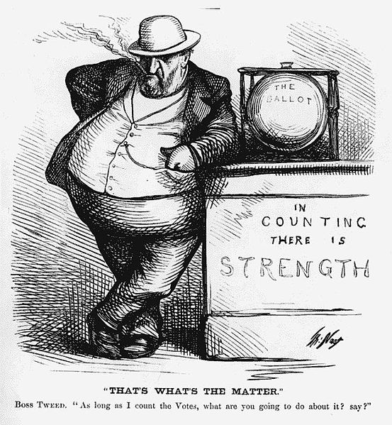DOC 2
(Check out THIS video for a quick review.)

Document Analysis Questions

1. What issue is the political cartoon bringing attention to?

2. What ultimately fixed this issue?

HAPPY Analysis

1. What is the Historical Circumstance of this cartoon?

2. Who is the intended Audience of this cartoon?

3. What is the Point of View of the cartoon?

4. What is the Purpose of this cartoon?

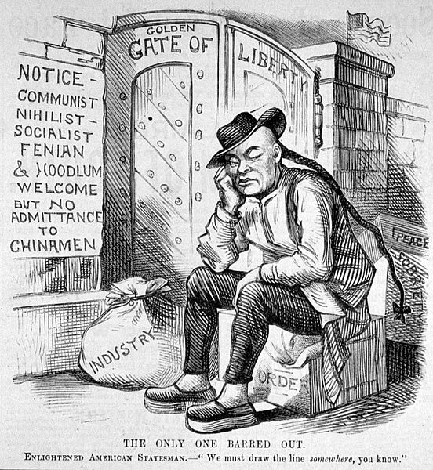 DOC 3
(Check out THIS video for a quick recap)

1. How would nativists view the cartoon?

2. What are character traits that the Chinese offer according to the cartoonist?

3. What were reasons that the Chinese were specifically barred from immigrating to America?

4. What are other examples of nativism in US History? (Potential synthesis point)
HAPPY Analysis

1. What is the Historical Circumstance of this cartoon?

2. Who is the Audience of this cartoon?

3. What is the Point of View of the cartoon?

4. What is the Purpose of this cartoon?

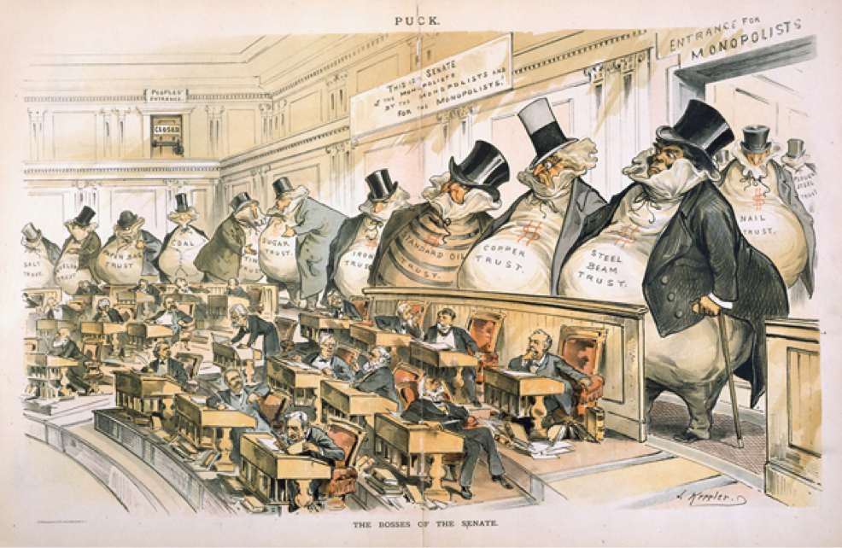DOC 4
(Check out THIS video for a quick recap)

1. What is the Historical Circumstance of this document? (What are events that happen prior to and afer this cartoon was published?)

2. Who is the intended Audience of this document? What kind of a magazine is PUCK? (this IS KEY!!)

3. What is the Point of View of the document?

4. What is the Purpose of this document?

DOC 5: “You come to us and tell us that the great cities are in favor of the gold standard. I tell you that the great cities rest upon these broad and fertile prairies. Burn down your cities and leave our farms, and your cities will spring up again as if by magic. But destroy our farms and the grass will grow in the streets of every city in the country….

Having behind us the commercial interests and the laboring interests and all the toiling masses, we shall answer their demands for a gold standard by saying to them, you shall not press down upon the brow of labor this crown of thorns. You shall not crucify mankind upon a cross of gold.”
- William Jennings Bryan, 1896

(Check out THIS video for a quick review.)

1. What is the Historical Circumstance of this document?

2. Who is the Audience of this document?

3. What is the Point of View of the document?

4. What is the Purpose of this document?

