Period 5 (1844 – 1877) Review Sheet
Chapters 16 – 23 of the American Pageant Textbook

Welcome to Period 5!
R
E
A
D

T
H
I
S

F
I
R
S
T
!

Potential Short Answer Questions/Essay Topics Include:
- How could The Mexican-American War be seen As A Turning Point?
- Causes and effects of Manifest Destiny
- Sectional tensions prior to the Civil War – for example, The Compromise of 1850, The Kansas-Nebraska Act, and The Dred Scott decision.
- How successful was Reconstruction?
- Ways Southern states resisted the 13 – 15 Amendments

Why were these years chosen for this period?
1844 marked the election of James K. Polk. Shortly after his election, Manifest Destiny was in full thrust as well as the Mexican-American War. Many have argued that this war was a Turning Point. After the Civil War ended, the US entered a time period known as Reconstruction, which ended in 1877.

Key vocabulary terms to know for this time period:

Reasons for westward migration (Manifest Destiny) - Access to natural and mineral resources, economic opportunities for settlers, religious refuge (Mormons).
Arguments to annex western lands included – Manifest Destiny and American institutions (democracy)
Impact US acquiring the Mexican Cession- Debates over the status of slavery (Wilmot Proviso), Native Americans, and Mexicans in the newly acquired land.
How did the government encourage westward migration?- Passing new legislation (think Homestead Act) encouraging settlers to move west, government gave land and subsidies to RR companies.
Goal of the Nativist Movement? - It was especially Anti-Catholic. The nativists hoped to limit the power and cultural influence of the immigrants (Irish and Germans).
What was the free soil movement? - Sought to keep slavery from expanding into newly acquired territories.
What were ways abolitionists campaigned against slavery? - Moral arguments (think William Lloyd Garrison), assisting slaves' escapes (think Underground RR), using violence (think Bleeding-Kansas and Harpers Ferry).
How did the South justify and defend slavery? – They claimed slavery was a positive good (John C. Calhoun).
What was the Compromise of 1850? - Dealt with the Mexican Cession - popular sovereignty would be used in the territory, slave trade was banned in Washington D.C., California was added as a free state, a more strict fugitive slave law was created.
What was the Kansas-Nebraska Act? - Overturned the MO Compromise - introduced popular sovereignty in Kansas and Nebraska. Helped lead to the creation of the Republican Party.
What did the Supreme Court rule in Dred Scott v. Sanford? – Slaves were property, not citizens; Congress could NOT legislate slavery in the territories.
What did Lincoln campaign on in the Election of 1860? – A free soil platform – non extension of slavery.
How did Lincoln’s views towards the war change over time? – Lincoln viewed the war initially as preserving the union, but eventually sought to end slavery -> Emancipation Proclamation and Gettysburg Address
How did the Union ultimately prevail in the Civil War? – Improvements in leadership and strategy (Grant and the “Anaconda Plan”), Key Victories – Gettysburg and Antietam; Greater resources – more factories and RRs, the South’s infrastructure was destroyed.
What did the 13 – 15 amendments do? – 13 – abolished slavery; 14 – granted citizenship and equal protection; 15 – universal adult male suffrage.
Why did the 15th amendment split the women’s rights movement? – Some women advocated suffrage be extended to women as well as African American males.
Why did Reconstruction end? – Compromise of 1877 withdrew troops from the South; The North’s WANING resolve led to many in the North to no longer support Reconstruction.
What is sharecropping? – Renting of land to former slaves – limited economic opportunities to former slaves and poor whites in the south.
What were ways the South resisted the 14th and 15th amendments? (Great Short Answer Question) – Segregation – Jim Crow laws; Violence – KKK and White League; Supreme Court Decisions – Plessy v. Ferguson (“Separate but equal”); Local political tactics – poll taxes, literacy tests, and grandfather clauses

Watch THIS video on Period 5 before you proceed. (10 minutes)

1. What is MANIFEST DESTINY?

2. How did territorial expansion lead to debates over slavery? (Need SPECIFIC historical evidence)

3. What are examples of nativism faced by “Old” immigrants?

4. How did the government encourage westward expansion during the time period?

5. Provide two examples of conflicts with Native Americans during this time period.

6. What were three ways abolitionists sought to achieve their goals?

7. How did the Mexican-American War contribute to tensions between the north and south?

8. How did the South defend slavery? Which groups were the most vocal?

9. Briefly explain how each of the following contributed to tensions over slavery:
- Compromise of 1850:
- Kansas-Nebraska Act:
- Dred Scott decision:

10. What was the purpose of John Brown’s raid at Harpers Ferry? What was the impact of this raid?

10. What was the significance of the Election of 1860?

11. What impact did the Emancipation Proclamation have on the Civil War?

12. What were three reasons or factors that led to the Union success in the Civil War?

13. Please describe the following Amendments:
- 13
- 14
- 15

14. What impact did the 15th amendment have on the women’s rights movement?

15. What are examples of African Americans gaining political opportunities during Reconstruction?

16. What does the word waning mean? What happened to the North’s resolve to continue with Reconstruction?

17. What were three ways Southern states limited the rights of African Americans?

18. Why did “Radical” Reconstruction occur? Which President was responsible for this? How did it succeed or fail? Why?

Document Analysis

Check out THIS VIDEO to review many documents from this period. More in-depth document analysis can be found on the following pages. Thank you.

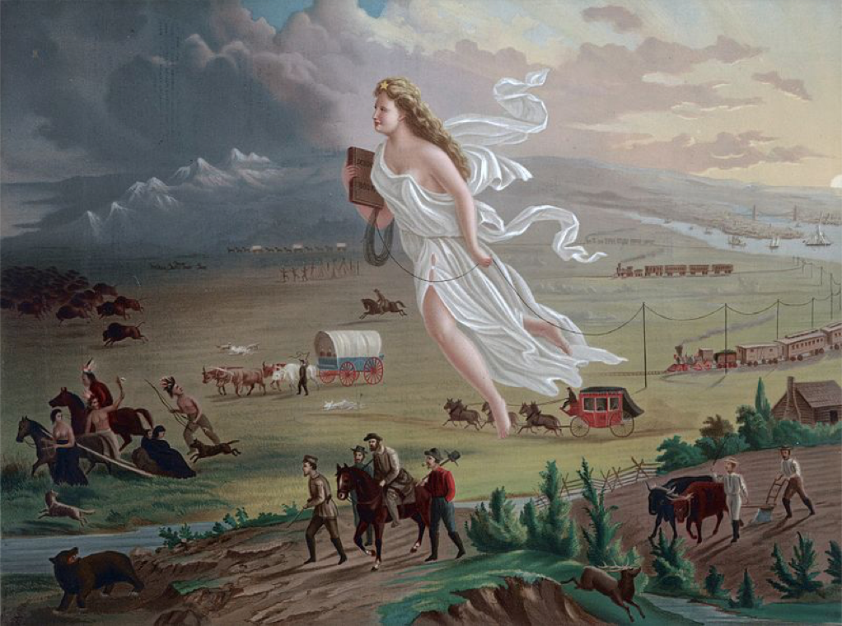Doc 1

Want more information on this topic? Click HERE to check out this video.

1. How would the following people view the image?
- Native Americans
- Frederick Jackson Turner
- Farmers hoping to prosper out west

2. What is the Historical Circumstance of this document?

3. Who is the Intended Audience of this document?

4. What is the Point of View of the document?

5. What is the Purpose of this document?

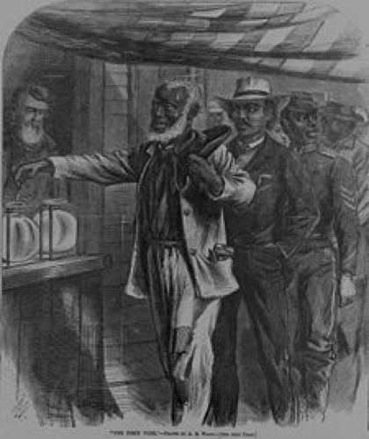
(Check out THIS video that breaks down the above document) – DOC 2
(post civil War)

1. What is the Historical Circumstance of this document?

2. Who is the Intended Audience of this document?

3. What is the Point of View of the document?

4. What is the Purpose of this document?

DOC 3: “Provided, That, as an express and fundamental condition to the acquisition of any territory from the Republic of Mexico by the United States, by virtue of any treaty which may be negotiated between them, and to the use by the Executive of the moneys herein appropriated, neither slavery nor involuntary servitude shall ever exist in any part of said territory, except for crime, whereof the party shall first be duly convicted.”
- Wilmot Proviso, 1846
(Check out THIS video that breaks down the above document)

1. What is the goal of the Wilmot Proviso?

2. How did Manifest Destiny contribute to debates over slavery, such as the Wilmot Proviso?

3. The Proviso was passed in the House of Representatives, but not the Senate. What does that tell us about the population distribution in the 1840s?

4. How would the following view the Wilmot Proviso?
- Southern Plantation Owners:
- Supporters of Popular Sovereignty:
- Members of the Free-Soil Party:
- Members of the Republican Party:

5. Where else in American History have we seen bans on slavery? (Besides the 13th amendment).

6. What is the Historical Circumstance of this document?

7. Who is the Intended Audience of this document?

8. What is the Point of View of the document?

9. What is the Purpose of this document?

