Period 4 (1800 – 1848) Review Sheet
Chapters 9 – 15 of the American Pageant Textbook

Welcome to Period 4!
R
E
A
D

T
H
I
S

F
I
R
S
T
!

Potential Short Answer Questions/Essay Topics Include:
- Causes and Impacts of the Market Revolution.
- Development of the 2nd Party System (Check out THIS video)
- Causes and Impacts of the Second Great Awakening
- Reasons for the growth of slavery and its effects (Check out THIS video)

Why were these years chosen for this period?

1800 marked the election of Thomas Jefferson, which some historians have called The Revolution of 1800. 1848 is the year the Seneca Falls Convention occurred and was also the year the Mexican-American War ended.

Key vocabulary terms to know for this time period:

Impact of the Supreme Court decisions of the early 1800s - The primacy of the judiciary in determining the meaning of the Constitution (think judicial review)) and giving federal laws power over state governments (think Gibbons v. Ogden and McCulloch v. Maryland)
Whigs and Democrats Disagreed over - Role and powers of the federal government, National Bank, tariffs, federally funded internal improvements (Think Henry Clay's American System)
Impact of the Second Great Awakening - Moral and social reforms (think abolitionism, women's rights, temperance, etc.)
Seneca Falls Convention- Women's Rights convention that sought greater equality (attended by men too such as Frederick Douglass)
New innovations during the Market Revolution - Textile machinery (spinning jenny), steam engines, interchangeable parts (Eli Whitney), telegraph, and agricultural inventions (cotton gin - Whitney again)
How did the Market Revolution change the production of goods? - Goods were increasingly made outside the home. Women and men began working in factories.
Where did immigrants settle? - Irish settled in northern cities, Germans settled on the frontier - worked as farmers (CINCINNATI!)
American System - Henry Clay!'s plan to unify the American economy. Focused on a 2nd BUS, Internal Improvements, and Tariffs. The north and midwest benefitted more than the south.
Monroe Doctrine - President Monroe's message to Europe to NOT colonize any new land in Latin America. The US would stay out of European affairs.
Missouri Compromise (Compromise of 1820) - 3 parts: Maine was a free state, Missouri was a slave state, everything above 3630 latitude line would be free, everything below would be slave. This applied to ONLY the Louisiana Purchase. Later overturned by the Kansas-Nebraska Act (possible synthesis point).
Watch THIS video on Period 4 before you proceed. (14 minutes)

1. What was the significance of Marbury v. Madison? (Check out THIS video for a quick recap)

2. How did the following Supreme Court Cases help establish the supremacy of federal over state laws? (Check out THIS video for a quick recap)
- McCulloch v. Maryland (1819):
- Gibbons v. Ogden (1824):

3. What were reasons for the growth of the Second Party System? (Democrats and Whigs). (Check out THIS video for a quick recap of the characteristics of the 2nd Party System)

4. Complete the chart below based on the Democrats and Whigs.
 | Democrats | Whigs
Role and Power of Federal Government
View of the National Bank (2nd BUS)
View of Tariffs
View of Federally funded Internal Improvements

5. Identify and briefly explain three impacts of the Second Great Awakening? (Check out THIS video for a recap of the Second Great Awakening)

6. How did African Americans protect their dignity and family structures?

7. Identify and describe three different abolitionists. (Check out THIS video for a quick recap)

8. Identify and explain two examples of slave rebellions between 1800 and 1848.

9. What was the goal of the Seneca Falls Convention? Did they achieve this goal? (Check out THIS video for a quick recap)

10. Identify and briefly explain two new technological innovations ruing the Market Revolution. (Check out THIS video for a recap of Market Revolution inventions).

11. What was the goal of Henry Clay’s American System? Was it successful? (Check out THIS video for a quick recap of the American System).

12. What was the message of the Monroe Doctrine?

13. How were Native Americans impacted as a result of westward expansion? (Provide SPECIFIC historical details – tribes, locations, battles/events)

14. What were the three parts of the Missouri Compromise? Why was it important for both the North and South to have the balance of states equal at 12? (Check out THIS video for a quick recap)

15. What is nativism? What are examples of this during Antebellum America? (Check out THIS video for a recap of nativism)

16. What two groups immigrated in large numbers to America in the 1830s and 1840s? Where did they tend to settle? (Check out THIS video for a recap of “Old” Immigration.)

17. What happened to the amount of Americans able to vote under Andrew Jackson’s Presidency? What groups were still not able to vote? (Check out THIS video for a quick recap of Jackson’s presidency)

18. How were tensions (Check out THIS video for a quick recap of the Nullification Crisis)

Document Analysis

DOC 1: “I am aware that many object to the severity of my language; but is there not cause for severity? I will be as harsh as truth, and as uncompromising as justice. On this subject, I do not wish to think, or speak, or write, with moderation. No! No! Tell a man whose house is on fire to give a moderate alarm; tell him to moderately rescue his wife from the hands of the ravisher; tell the mother to gradually extricate her babe from the fire into which it has fallen;—but urge me not to use moderation in a cause like the present. I am in earnest—I will not equivocate—I will not excuse—I will not retreat a single inch—AND I WILL BE HEARD. The apathy of the people is enough to make every statue leap from its pedestal, and to hasten the resurrection of the dead.”
— William Lloyd Garrison, "To the Public," from the Inaugural Editorial in the January 1, 1831, issue of The Liberator
(Check out THIS video that breaks down the above document.)

1. How does Garrison justify his approach towards slavery?

2. Would the following support or oppose Garrison’s message? Why?
- American Colonization Society:

- Southern Plantation Owners:

- Those that supported the Women’s Rights Movement:

3. What were arguments used by the South to counter Garrison’s message?

DOC 2: “[T]his momentous question, like a firebell in the night, awakened and filled me with terror. I considered it, at once as the [death] knell of the Union. It is hushed, indeed, for the moment. But this is a reprieve only, not a final sentence. A geographical line, coinciding with a marked principle, moral and political, once conceived and held up to the angry passions of men, will never be obliterated; and every new irritation will mark it deeper and deeper.”
-- Source: Thomas Jefferson to John Randolph, April 22, 1820
(Check out THIS video that breaks down the above document)

1. What is the Historical Context of this document?

2. What is the Purpose of this document?

DOC 3: “We hold these truths to be self-evident: that all men and women are created equal; that they are endowed by their Creator with certain inalienable rights; that among these are life, liberty, and the pursuit of happiness…..

The history of mankind is a history of repeated injuries and usurpation on the part of man toward woman, having in direct object the establishment of an absolute tyranny over her. To prove this, let facts be submitted to a candid world…

- He has not ever permitted her to exercise her inalienable right to the elective franchise.
- He has compelled her to submit to laws, in the formation of which she had no voice.
- Having deprived her of this first right as a citizen, the elective franchise, thereby leaving her without representation in the halls of legislation, he has oppressed her on all sides.
- He has made her, if married, in the eye of the law, civilly dead.
- He has taken from her all right in property, even to the wages she earns.
- He has denied her the facilities for obtaining a thorough education—all colleges being closed against her.
- Declaration of Sentiments (1848)
(Check out THIS video that breaks down the above document)

1. What document was the Declaration of Sentiments inspired by? How do you know? Why might the authors chosen to have done this?

1. What is the Historical Circumstance of this document?

2. Who is Audience of this document?

3. What is the Point of View of the document?

4. What is the Purpose of this document?

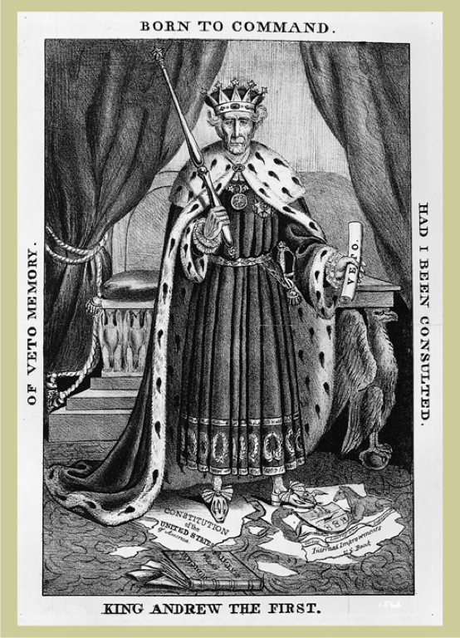
-- “King Andrew I”
(Check out THIS video that breaks down the above political cartoon)

1. What is the point of view of the cartoon? (Positive? Negative? How do you know?)

2. What political party would support the image above?

3. What political party would oppose the image above?

4. Would the following people/groups agree or disagree with the depiction of Andrew Jackson in the image? Why?
- Native Americans such as the Cherokees:
- Individuals that opposed the Bank of the US:
- John C. Calhoun and his supporters:

DOC 4: “The committee [of the South Carolina Legislature] have bestowed on the subjects referred to them the deliberate attention which their importance demands; and the result, on full investigation, is a unanimous opinion that the act of Congress of the last session, with the whole system of legislation imposing duties on imports, not for revenue, but the protection of one branch of industry at the expense of others, is unconstitutional, unequal, and oppressive, and calculated to corrupt the public virtue and destroy the liberty of the country; which propositions they propose to consider in the order stated, and then to conclude their report with the consideration of the important question of the remedy.”
-- South Carolina Exposition and Protest, 1828

1. What issue does the South Carolina legislature have with Congress?

2. What region(s) of the country would agree with the message?

3. What region(s) of the country would disagree with the message?

4. Does this document support the American System? How do you know?

5. What is the Historical Circumstance of this document?

6. Who is the Audience of this document?

7. What is the Point of View of the document?

8. What is the Purpose of this document?

DOC 5

(Check out THIS video that breaks down the above political cartoon)

- What is the Historical Circumstance of this document?

- Who is the Intended Audience of this document?

- What is the Point of View of the document?

- What is the Purpose of this document?

