DBQ Practice #7
Evaluate the relative importance of different causes for the expanding role of the United States in the world in the period from 1865 to 1910.
Document 1
Source: Treaty concerning the Cession of the Russian Possessions in North America by his Majesty the Emperor of all the Russias to the United States of America, June 20, 1867.
His Majesty the Emperor of all the Russias agrees to cede to the United States, by this convention, immediately upon the exchange of the ratifications thereof, all the territory and dominion now possessed by his said Majesty on the continent of America and in the adjacent islands, the same being contained within the geographical limits herein set forth....
The inhabitants of the ceded territory, according to their choice . . . may return to Russia within three years; but if they should prefer to remain in the ceded territory, they, with the exception of uncivilized native tribes, shall be admitted to the enjoyment of all the rights, advantages, and immunities of citizens of the United States, and shall be maintained and protected in the free enjoyment of their liberty, property, and religion. The uncivilized tribes will be subject to such laws and regulations as the United States may, from time to time, adopt in regard to aboriginal tribes of that country....
In consideration of the cession aforesaid, the United States agree to pay . . . seven million two hundred thousand dollars in gold.
Document 2
Source: Josiah Strong, Our Country: Its Possible Future and Its Present Crisis, 1885.
It seems to me that God, with infinite wisdom and skill, is training the Anglo-Saxon race for an hour sure to come in the world’s future. Heretofore there has always been in the history of the world a comparatively unoccupied land westward, into which the crowded countries of the East have poured their surplus populations. But the widening waves of migration, which millenniums ago rolled east and west from the valley of the Euphrates, meet today on our Pacific coast. There are no more new worlds. The unoccupied arable lands of the earth are limited, and will soon be taken. The time is coming when the pressure of population on the means of subsistence will be felt here as it is now felt in Europe and Asia. Then will the world enter upon a new stage of its history—the final competition of races, for which the Anglo-Saxon is being schooled.... Then this race of unequaled energy, with all the majesty of numbers and the might of wealth behind it—the representative, let us hope, of the largest liberty, the purest Christianity, the highest civilization—having developed peculiarly aggressive traits calculated to impress its institutions upon mankind, will spread itself over the earth.
Document 3
Source: Captain Alfred Thayer Mahan, The Interest of America in Sea Power, Present and Future, 1897.
To affirm the importance of distant markets, and the relation to them of our own immense powers of production, implies logically the recognition of the link that joins the products and the markets,—that is, the carrying trade; the three together constituting that chain of maritime power to which Great Britain owes her wealth and greatness. Further, is it too much to say that, as two of these links, the shipping and the markets, are exterior to our own borders, the acknowledgment of them carries with it a view of the relations of the United States to the world radically distinct from the simple idea of self-sufficingness?... There will dawn the realization of America’s unique position, facing the older worlds of the East and West, her shores washed by the oceans which touch the one or the other, but which are common to her alone.
Despite a certain great original superiority conferred by our geographical nearness and immense resources,—due, in other words, to our natural advantages, and not to our intelligent preparations,—the United States is woefully unready, not only in fact but in purpose, to assert in the Caribbean and Central America a weight of influence proportioned to the extent of her interests. We have not the navy, and, what is worse, we are not willing to have the navy, that will weigh seriously in any disputes with those nations whose interests will conflict there with our own. We have not, and we are not anxious to provide, the defence of the seaboard which will leave the navy free for its work at sea. We have not, but many other powers have, positions, either within or on the borders of the Caribbean.
Document 4
Source: Puck. A Satirical Magazine, 1910.
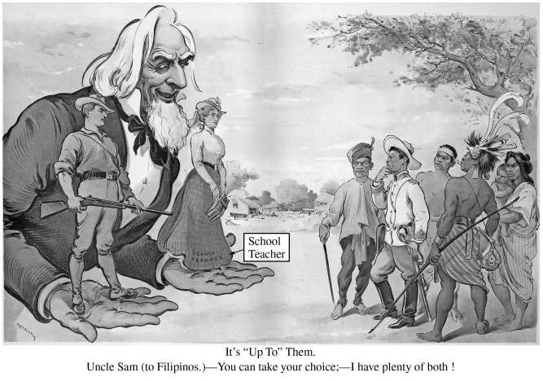
Document 5
Source: John Hay, United States Secretary of State, The Second Open Door Note, July 3, 1900.
To the Representatives of the United States at Berlin, London, Paris, Rome, St. Petersburg, and Tokyo Washington, July 3, 1900
In this critical posture of affairs in China it is deemed appropriate to define the attitude of the United States as far as present circumstances permit this to be done. We adhere to the policy . . . of peace with the Chinese nation, of furtherance of lawful commerce, and of protection of lives and property of our citizens by all means guaranteed under extraterritorial treaty rights and by the law of nations. . . . We regard the condition at Pekin[g] as one of virtual anarchy. . . . The purpose of the President is . . . to act concurrently with the other powers; first, in opening up communication with Pekin[g] and rescuing the American officials, missionaries, and other Americans who are in danger; secondly, in affording all possible protection everywhere in China to American life and property; thirdly, in guarding and protecting all legitimate American interests; and fourthly, in aiding to prevent a spread of the disorders to the other provinces of the Empire and a recurrence of such disasters. . . . The policy of the Government of the United States is to seek a solution which may bring about permanent safety and peace to China, preserve Chinese territorial and administrative entity, protect all rights guaranteed to friendly powers by treaty and international law, and safeguard for the world the principle of equal and impartial trade with all parts of the Chinese Empire.

