Europe After World War II
At the end of the war, millions of people were homeless, the European economy had collapsed, and much of the continent’s industrial infrastructure had been destroyed.

LEARNING OBJECTIVES
Describe the condition of the European continent after World War II

KEY TAKEAWAYS

Key Points
- The aftermath of World War II was the beginning of an era defined by the decline of the old great powers and the rise of two superpowers: the Soviet Union (USSR) and the United States of America (U.S.), who soon entered the Cold War.
- The Allies established occupation administrations in Germany, divided into western and eastern occupation zones controlled by the Western Allies and the USSR accordingly.
- A denazification program in Germany led to the prosecution of Nazi war criminals and the removal of ex-Nazis from power, along with a “industrial disarmament” of the German economy, initially leading to economic stagnation.
- After a few years, the U.S. and the other Allied power rescinded on this attitude toward Germany and instead focused on economic support.
- Recovery began with the mid-1948 currency reform in Western Germany, and was sped up by the liberalization of European economic policy both directly and indirectly caused by the Marshall Plan (1948–1951).

Key Terms
- German economic miracle: Also known as The Miracle on the Rhine, the rapid reconstruction and development of the economies of West Germany and Austria after World War II.
- Marshall Plan: An American initiative to aid Western Europe in which the United States gave more than $12 billion in economic support to help rebuild Western European economies after the end of World War II.

Overview
The aftermath of World War II was the beginning of an era defined by the decline of the old great powers and the rise of two superpowers: the Soviet Union (USSR) and the United States of America (U.S.), creating a bipolar world. Allied during World War II, the U.S. and USSR became competitors on the world stage and engaged in the Cold War, so-called because it never boiled over into open war between the two powers but was focused on espionage, political subversion, and proxy wars. Western Europe and Japan were rebuilt through the American Marshall Plan whereas Eastern Europe fell in the Soviet sphere of influence and rejected the plan. Europe was divided into a U.S.-led Western Bloc and a Soviet-led Eastern Bloc.
As a consequence of the war, the Allies created the United Nations, a new global organization for international cooperation and diplomacy. Members of the United Nations agreed to outlaw wars of aggression to avoid a third world war. The devastated great powers of Western Europe formed the European Coal and Steel Community, which later evolved into the European Common Market and ultimately into the current European Union. This effort primarily began as an attempt to avoid another war between Germany and France by economic cooperation and integration and as a common market for important natural resources.

Occupation and Territory Reallocation
The Allies established occupation administrations in Austria and Germany. The former became a neutral state, non-aligned with any political bloc. The latter was divided into western and eastern occupation zones controlled by the Western Allies and the USSR accordingly. A denazification program in Germany led to the prosecution of Nazi war criminals and the removal of ex-Nazis from power, although this policy moved towards amnesty and reintegration of ex-Nazis into West German society.
Germany lost a quarter of its prewar (1937) territory. Among the eastern territories, Silesia, Neumark, and most of Pomerania were taken over by Poland; East Prussia was divided between Poland and the USSR and 9 million Germans expelled from these provinces; and 3 million Germans from the Sudetenland in Czechoslovakia to Germany. By the 1950s, every fifth West German was a refugee from the east. The Soviet Union also took over the Polish provinces east of the Curzon line, from which 2 million Poles were expelled; northeast Romania, parts of eastern Finland, and the three Baltic states were also incorporated into the USSR.

Economic Aftermath
By the end of the war, the European economy had collapsed and 70% of the industrial infrastructure was destroyed. The property damage in the Soviet Union consisted of complete or partial destruction of 1,710 cities and towns, 70,000 villages, and 31,850 industrial establishments. The strength of the economic recovery following the war varied throughout the world, though in general it was quite robust. In Europe, West Germany declined economically during the first years of the Allied occupation but later experienced a remarkable recovery, and had by the end of the 1950s doubled production from its prewar levels. Italy came out of the war in poor economic condition, but by the 1950s, the Italian economy was marked by stability and high growth. France rebounded quickly and enjoyed rapid economic growth and modernization under the Monnet Plan. The UK, by contrast, was in a state of economic ruin after the war and continued to experience relative economic decline for decades to follow.
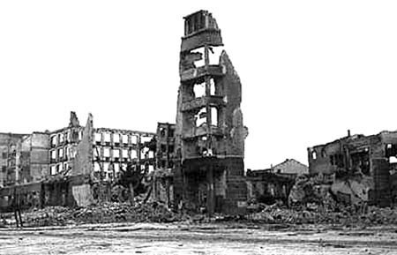
Stalingrad Aftermath: Ruins in Stalingrad, typical of the destruction in many Soviet cities.
The U.S. emerged much richer than any other nation and dominated the world economy; it had a baby boom and by 1950 its gross domestic product per person was much higher than that of any of the other powers. The UK and US pursued a policy of industrial disarmament in Western Germany in the years 1945–1948. International trade interdependencies thus led to European economic stagnation and delayed the continent’s recovery for several years.
U.S. policy in post-war Germany from April 1945 until July 1947 was to give the Germans no help in rebuilding their nation, save for the minimum required to mitigate starvation. The Allies’ immediate post-war “industrial disarmament” plan for Germany was to destroy Germany’s capability to wage war by complete or partial deindustrialization. The first industrial plan for Germany, signed in 1946, required the destruction of 1,500 manufacturing plants to lower heavy industry output to roughly 50% of its 1938 level. Dismantling of West German industry ended in 1951. By 1950, equipment had been removed from 706 manufacturing plants and steel production capacity had been reduced by 6.7 million tons.
After lobbying by the Joint Chiefs of Staff and Generals Lucius D. Clay and George Marshall, the Truman administration accepted that economic recovery in Europe could not go forward without the reconstruction of the German industrial base on which it had previously been dependent. In July 1947, President Truman rescinded on “national security grounds” the directive that ordered the U.S. occupation forces to “take no steps looking toward the economic rehabilitation of Germany.” A new directive recognized that “[a]n orderly, prosperous Europe requires the economic contributions of a stable and productive Germany.”
Recovery began with the mid-1948 currency reform in Western Germany and was sped up by the liberalization of European economic policy that the Marshall Plan (1948–1951) both directly and indirectly caused. The post-1948 West German recovery has been called the German economic miracle.

The Long Telegram
In February 1946, George F. Kennan’s “Long Telegram” from Moscow helped articulate the U.S. government’s increasingly hard line against the Soviets and became the basis for the U.S. “containment” strategy toward the Soviet Union for the duration of the Cold War.

LEARNING OBJECTIVES
Recall the significance of the Long Telegram

KEY TAKEAWAYS

Key Points
- In February 1946, the U.S. State Department asked George F. Kennan, then at the U.S. Embassy in Moscow, why the Russians opposed the creation of the World Bank and the International Monetary Fund.
- Kennan responded with a wide-ranging analysis of Russian policy now called the “Long Telegram.”
- In the “Long Telegram,” Kennan emphasized that the Soviet Union did not see the possibility for long-term peaceful coexistence with the capitalist world and that the best strategy was to “contain” communist expansion around the globe.
- A year later, Kennan published an article under the anonymous pseudonym “X” summarizing and clarifying his analysis in the “Long Telegram.”
- The attitudes and strategies promoted in these two documents, namely the strategy of ” containment,” formed the basis of America’s approach to the USSR for the most of the Cold War.

Key Terms
- containment: A military strategy to stop the expansion of an enemy. It is best known as the Cold War policy of the United States and its allies to prevent the spread of communism.
- “Long Telegram”: A 1946 cable telegram by U.S. diplomat George F. Kennan during the post-WWII administration of U.S. President Harry Truman that articulated the policy of containment toward the USSR.

Overview
The first phase of the Cold War began in the first two years after the end of the Second World War in 1945. The USSR consolidated its control over the states of the Eastern Bloc, while the United States began a strategy of global containment to challenge Soviet power, extending military and financial aid to the countries of Western Europe. An important moment in the development of America’s initial Cold War strategy was the delivery of the “Long Telegram” sent from Moscow by American diplomat George Kennan in 1946.
Kennan’s “Long Telegram” and the subsequent 1947 article “The Sources of Soviet Conduct” argued that the Soviet regime was inherently expansionist and that its influence had to be “contained” in areas of vital strategic importance to the United States. These texts provided justification for the Truman administration’s new anti-Soviet policy. Kennan played a major role in the development of definitive Cold War programs and institutions, notably the Marshall Plan.

The “Long Telegram”
In Moscow, Kennan felt his opinions were being ignored by Harry S. Truman and policymakers in Washington. Kennan tried repeatedly to persuade policymakers to abandon plans for cooperation with the Soviet government in favor of a sphere of influence policy in Europe to reduce the Soviets’ power there. Kennan believed that a federation needed to be established in western Europe to counter Soviet influence in the region and compete against the Soviet stronghold in eastern Europe.
Kennan served as deputy head of the mission in Moscow until April 1946. Near the end of that term, the Treasury Department requested that the State Department explain recent Soviet behavior, such as its disinclination to endorse the International Monetary Fund and the World Bank. Kennan responded on February 22, 1946, by sending a 5,500-word telegram (sometimes cited as more than 8,000 words) from Moscow to Secretary of State James Byrnes outlining a new strategy for diplomatic relations with the Soviet Union.
Kennan described dealing with Soviet Communism as “undoubtedly the greatest task our diplomacy has ever faced and probably the greatest it will ever have to face.” In the first two sections, he posited concepts that became the foundation of American Cold War policy:
- The USSR perceived itself at perpetual war with capitalism.
- The USSR viewed left-wing, but non-communist, groups in other countries as an even worse enemy than the capitalist ones.
- The USSR would use controllable Marxists in the capitalist world as allies.
- Soviet aggression was fundamentally not aligned with the views of the Russian people or with economic reality, but rooted in historic Russian nationalism and neurosis.
- The Soviet government’s structure inhibited objective or accurate pictures of internal and external reality.
According to Kennan, the Soviet Union did not see the possibility for long-term peaceful coexistence with the capitalist world; its ever-present aim was to advance the socialist cause. Capitalism was a menace to the ideals of socialism, and capitalists could not be trusted or allowed to influence the Soviet people. Outright conflict was never ca desirable avenue for the propagation of the Soviet cause, but their eyes and ears were always open for the opportunity to take advantage of “diseased tissue” anywhere in the world.
In Section Five, Kennan exposited Soviet weaknesses and proposed U.S. strategy, stating that despite the great challenge, “my conviction that problem is within our power to solve—and that without recourse to any general military conflict.” He argued that the Soviet Union would be sensitive to force, that the Soviets were weak compared to the united Western world, that the Soviets were vulnerable to internal instability, and that Soviet propaganda was primarily negative and destructive.
The solution was to strengthen Western institutions in order to render them invulnerable to the Soviet challenge while awaiting the mellowing of the Soviet regime.

The X Article
Unlike the “Long Telegram,” Kennan’s well-timed article in the July 1947 issue of Foreign Affairs attributed the pseudonym “X,” entitled “The Sources of Soviet Conduct,” did not begin by emphasizing “traditional and instinctive Russian sense of insecurity”; instead, it asserted that Stalin’s policy was shaped by a combination of Marxist and Leninist ideology, which advocated revolution to defeat the capitalist forces in the outside world and Stalin’s determination to use the notion of “capitalist encirclement” to legitimize his regimentation of Soviet society so that he could consolidate his political power. Kennan argued that Stalin would not (and moreover could not) moderate the supposed Soviet determination to overthrow Western governments. Thus,
the main element of any United States policy toward the Soviet Union must be a long-term, patient but firm and vigilant containment of Russian expansive tendencies… Soviet pressure against the free institutions of the Western world is something that can be contained by the adroit and vigilant application of counterforce at a series of constantly shifting geographical and political points, corresponding to the shifts and manoeuvers of Soviet policy, but which cannot be charmed or talked out of existence.
The publication of the “X Article” soon began one of the more intense debates of the Cold War. Walter Lippmann, a leading American commentator on international affairs, strongly criticized the “X Article.” He argued that Kennan’s strategy of containment was “a strategic monstrosity” that could “be implemented only by recruiting, subsidizing and supporting a heterogeneous array of satellites, clients, dependents, and puppets.” Lippmann argued that diplomacy should be the basis of relations with the Soviets; he suggested that the U.S. withdraw its forces from Europe and reunify and demilitarize Germany. Meanwhile, it was revealed informally that “X” was indeed Kennan. This information seemed to give the “X Article” the status of an official document expressing the Truman administration’s new policy toward the USSR. In the years that followed, this implication was proved correct by the actions taken by the U.S. government toward foreign affairs, including entering the Korean War and the Vietnam War.
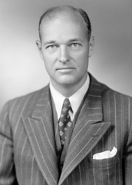
George F. Kennan: George F. Kennan in 1947, the year the “X Article” was published.

The Iron Curtain
On March 5, 1946, Winston Churchill gave a speech declaring that an “iron curtain” had descended across Europe, pointing to efforts by the Soviet Union to block itself and its satellite states from open contact with the West.

LEARNING OBJECTIVES
Explain the term Iron Curtain

KEY TAKEAWAYS

Key Points
- The antagonism between the Soviet Union and the West that came to be described as the “iron curtain” had various origins, including events going back to the Russian Revolution of 1917, disagreements during and immediately after WWII, and various annexations of Eastern European nations by the Soviet Union.
- The Iron Curtain specifically refers to the imaginary line dividing Europe between Soviet influence and Western influence, and symbolizes efforts by the Soviet Union to block itself and its satellite states from open contact with the West and non-Soviet-controlled areas.
- On either side of the Iron Curtain, states developed their own international military alliances, namely the Warsaw Pact and NATO.
- Physically, the Iron Curtain took the form of border defenses between the countries of Europe in the middle of the continent, most notably the Berlin Wall.

Key Terms
- “iron curtain”: A term indicating the imaginary boundary dividing Europe into two separate areas from the end of World War II in 1945 until the end of the Cold War in 1991.
- Warsaw Pact: A collective defense treaty among the Soviet Union and seven other Soviet satellite states in Central and Eastern Europe during the Cold War.
- NATO: An intergovernmental military alliance signed on April 4, 1949 and including the five Treaty of Brussels states (Belgium, the Netherlands, Luxembourg, France, and the United Kingdom) plus the United States, Canada, Portugal, Italy, Norway, Denmark, and Iceland.

Overview
The Iron Curtain formed the imaginary boundary dividing Europe into two separate areas from the end of World War II in 1945 until the end of the Cold War in 1991. The term symbolized efforts by the Soviet Union to block itself and its satellite states from open contact with the West and non-Soviet-controlled areas. On the east side of the Iron Curtain were the countries connected to or influenced by the Soviet Union. On either side of the Iron Curtain, states developed their own international economic and military alliances:
- Member countries of the Council for Mutual Economic Assistance and the Warsaw Pact, with the Soviet Union as the leading state
- Member countries of the North Atlantic Treaty Organization (NATO) with the United States as the preeminent power
Physically, the Iron Curtain took the form of border defenses between the countries of Europe in the middle of the continent. The most notable border was marked by the Berlin Wall and its “Checkpoint Charlie,” which served as a symbol of the Curtain as a whole.

Background
The antagonism between the Soviet Union and the West that came to be described as the “iron curtain” had various origins.
The Allied Powers and the Central Powers backed the White movement against the Bolsheviks during the 1918–1920 Russian Civil War, a fact not forgotten by the Soviets.
A series of events during and after World War II exacerbated tensions, including the Soviet-German pact during the first two years of the war leading to subsequent invasions, the perceived delay of an amphibious invasion of German-occupied Europe, the western Allies’ support of the Atlantic Charter, disagreement in wartime conferences over the fate of Eastern Europe, the Soviets’ creation of an Eastern Bloc of Soviet satellite states, western Allies scrapping the Morgenthau Plan to support the rebuilding of German industry, and the Marshall Plan.
In the course of World War II, Stalin determined to acquire a buffer area against Germany, with pro-Soviet states on its border in an Eastern bloc. Stalin’s aims led to strained relations at the Yalta Conference (February 1945) and the subsequent Potsdam Conference (August 1945). People in the West expressed opposition to Soviet domination over the buffer states, leading to growing fear that the Soviets were building an empire that might threaten them and their interests.
Nonetheless, at the Potsdam Conference, the Allies assigned parts of Poland, Finland, Romania, Germany, and the Balkans to Soviet control or influence. In return, Stalin promised the Western Allies he would allow those territories the right to national self-determination. Despite Soviet cooperation during the war, these concessions left many in the West uneasy. In particular, Churchill feared that the United States might return to its prewar isolationism, leaving the exhausted European states unable to resist Soviet demands.

Iron Curtain Speech
Winston Churchill’s “Sinews of Peace” address of March 5, 1946, at Westminster College, used the term “iron curtain” in the context of Soviet-dominated Eastern Europe:
From Stettin in the Baltic to Trieste in the Adriatic an “Iron Curtain” has descended across the continent. Behind that line lie all the capitals of the ancient states of Central and Eastern Europe. Warsaw, Berlin, Prague, Vienna, Budapest, Belgrade, Bucharest and Sofia; all these famous cities and the populations around them lie in what I must call the Soviet sphere, and all are subject, in one form or another, not only to Soviet influence but to a very high and in some cases increasing measure of control from Moscow.
Churchill mentioned in his speech that regions under the Soviet Union’s control were expanding their leverage and power without any restriction. He asserted that to put a brake on this phenomenon, the commanding force of and strong unity between the UK and the U.S. was necessary.
Much of the Western public still regarded the Soviet Union as a close ally in the context of the recent defeat of Nazi Germany and of Japan. Although not well received at the time, the phrase iron curtain gained popularity as a shorthand reference to the division of Europe as the Cold War strengthened. The Iron Curtain served to keep people in and information out, and people throughout the West eventually came to accept the metaphor.
Stalin took note of Churchill’s speech and responded in Pravda (the official newspaper of the Communist Party of the Soviet Union) soon afterward. He accused Churchill of warmongering, and defended Soviet “friendship” with eastern European states as a necessary safeguard against another invasion. He further accused Churchill of hoping to install right-wing governments in eastern Europe to agitate those states against the Soviet Union. Andrei Zhdanov, Stalin’s chief propagandist, used the term against the West in an August 1946 speech:
Hard as bourgeois politicians and writers may strive to conceal the truth of the achievements of the Soviet order and Soviet culture, hard as they may strive to erect an iron curtain to keep the truth about the Soviet Union from penetrating abroad, hard as they may strive to belittle the genuine growth and scope of Soviet culture, all their efforts are foredoomed to failure.
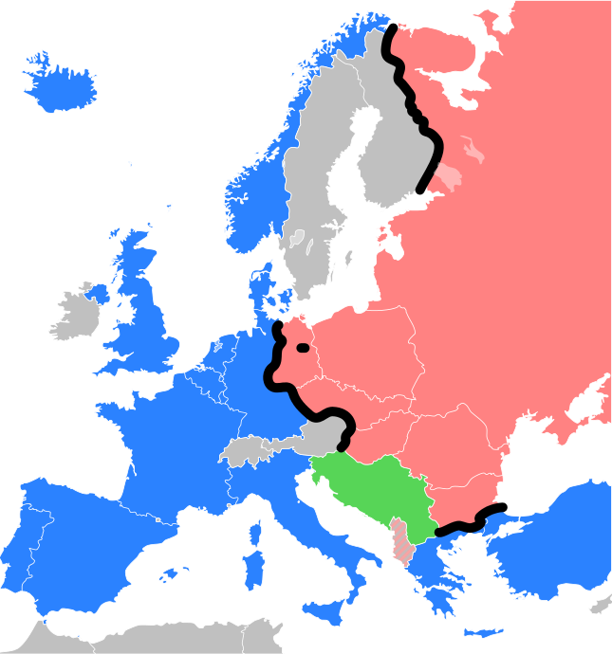
Iron Curtain: The Iron Curtain depicted as a black line. Warsaw Pact countries on one side of the Iron Curtain appear shaded red; NATO members on the other shaded blue; militarily neutral countries shaded gray. The black dot represents Berlin. Yugoslavia, although communist-ruled, remained largely independent of the two major blocs and is shaded green. Communist Albania broke off contacts with the Soviet Union in the early 1960s, aligning itself with the People’s Republic of China after the Sino-Soviet split; it appears stripe-hatched with grey.

