Chapter 29 Questions

- What was the general attitude of most Americans regarding international affairs before the 1880’s? P. 641

- Why did Americans begin to look towards territorial expansion? P. 641

- What did Alfred Thayer Mahan argue for? Why? P. 642

- What interests did Americans have in Hawaii? P 645

- How did the McKinley Tariff lead many planters to look toward annexation? P. 645

- What role did yellow journalism play in creating war fever?

- How did the mass media cover the events surrounding the USS Maine explosion?

- What was McKinley’s attitude regarding a possible war with Spain?

- Who decided that the United States Navy should lead an attack on the Philippines? P. 650

- Who were the “Rough Riders” and what was their role in the war? P. 651

- What did the United States decide to do regarding the Philippines? P. 654

- What was the Anti-Imperialist League and what were their arguments? P. 655

- How did the Platt Amendment ensure U.S. involvement in Cuban affairs? P. 657

- How did the war change the image of the United States abroad? P. 657

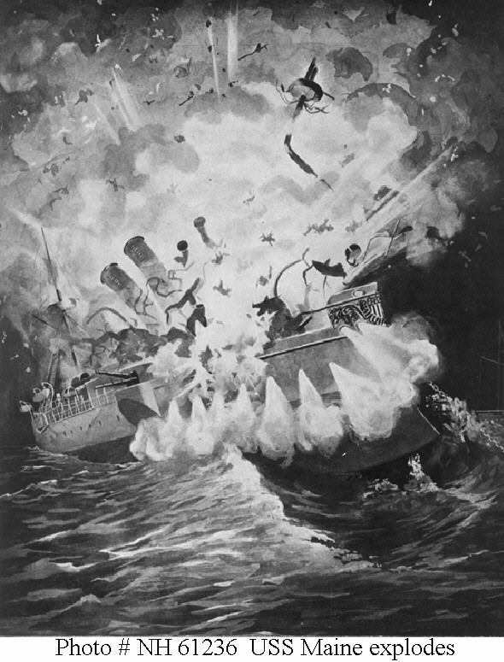

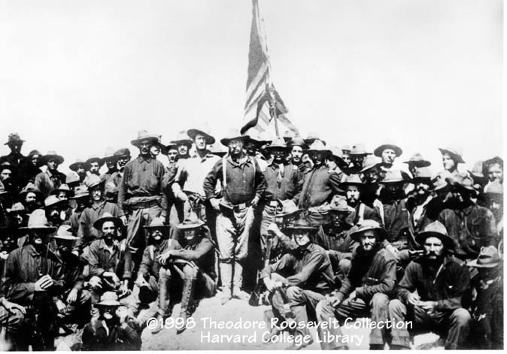

Former Assistant Secretary of the Navy Theodore Roosevelt and his volunteer cavalry…
The “Rough Riders”—Spanish American War, 1898

