APUSH Practice DBQ #5

Evaluate the extent to which transportation innovation contributed to American national unity in the period from 1800 to 1860.

Document 1
Source: Robert Fulton, inventor, to Albert Gallatin, Secretary of the Treasury, letter, 1807.
Having . . . considered the advantages which canals will produce in point of wealth to individuals and the nation, I will now consider their importance to the union and their political consequences.
. . . Numerous have been the speculations on the duration of our union, and intrigues have been practiced to sever the western from the eastern states. The opinion endeavored to be inculcated, was, that the inhabitants beyond the mountains were cut off from the market of the Atlantic states; that consequently they had a separate interest, and should use their resources to open a communication to a market of their own; that remote from the seat of government they could not enjoy their portion of advantages arising from the union, and that sooner or later they must separate and govern for themselves.
. . . What stronger bonds of union can be invented than those which enable each individual to transport the produce of his industry 1,200 miles for 60 cents the hundred weight? Here then is a certain method of securing the union of the states, and of rendering it as lasting as the continent we inhabit.
Document 2
Source: Thomas Jefferson to William Branch Giles, letter discussing the United States Supreme Court decision in Gibbons v. Ogden, December 1825.
Take together the decisions of the federal court, the doctrines of the President, and the misconstructions of the constitutional compact, acted on by the legislature of the federal branch and it is but too evident that the three ruling branches of that department are in combination to strip their Colleagues, the States authorities of the powers reserved by them. . . . Under the power to regulate Commerce they assume indefinitely that also over agriculture and manufactures. . . . Under the authority to establish post roads, they claim that of cutting down mountains for the construction of roads, of digging canals, and, aided by a little sophistry on the words “general welfare” a right to do, not only the acts to effect that which are specifically enumerated and permitted, but whatsoever they shall think, or pretend will be for the general welfare. . . . The states should be watchful to note every material usurpation on their rights, [and] to denounce them as they occur.
Document 3
Source: Samuel Breck, member of the Pennsylvania Senate and former member of the United States House of Representatives, journal entry, 1833.
As an instance of the rapid manner in which travelers get along, I may instance Mrs. Lloyd's trip to Richmond in Virginia. She left Philadelphia at six o'clock A.M. . . . and arrived in the evening of the second day from Philadelphia at the city of Richmond, thus traversing without fatigue a distance of five hundred miles in a little more than thirty-six hours!
Undoubtedly, a traveler will be able to go from Baltimore to New York by the light of a summer's sun when the locomotives shall be placed on the Amboy [New Jersey] railroad. An invitation to a three-o'clock dinner in New York or Philadelphia may now be complied with by the individual who takes his breakfast in either of these cities; and with the loco[motive], when established, he may start from one city in the morning and return again in the evening from a visit to the other.
Document 4
Source: Engraving in James S. Buckingham, English traveler, The Slave States of America, 1842.
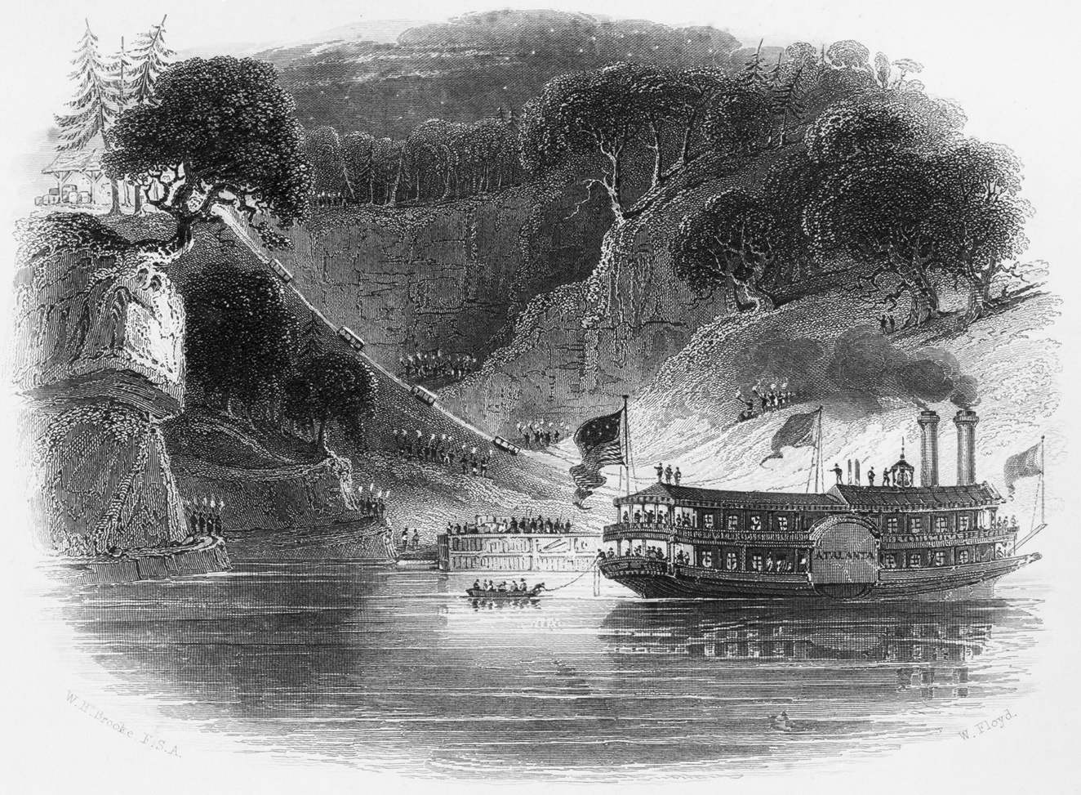
The engraving Slaves Shipping Cotton by Torch-Light depicts the loading of cargo on the Alabama River, bound for the port of Mobile, Alabama, on the Gulf of Mexico.
Document 5
Source: Jesse Chickering, political economist, Immigration into the United States, 1848.
We have . . . arrived at a period in the history of foreign immigration, when the number of foreigners coming here, one half of whom may be considered adults, nearly equals the whole natural increase of the white population of the United States. Such a mass of population annually diffused among these states, must . . . have most important effects on the condition and character of the people.
. . . The moral and physical condition of these immigrants, after undergoing many trials, which are to be expected from settling in a foreign country, is generally very much improved. . . . But is the country truly benefitted by this great foreign immigration? Have the people been made wiser or better or happier? It has been said that without these foreigners our rail-roads and canals could not have been constructed. . . . [But] the progress of the internal improvements, a year or two in advance of what they would have been without this foreign labor, will be a very poor compensation, if offset by the corruption of manners, the forfeiture of freedom, and the transfer of power to those who know not how to use it wisely.

