APUSH Sample DBQ #13

PROMPT
Analyze the continuity and change in the federal government’s approach to the regulation of big business between the 1870s and the 1910s.

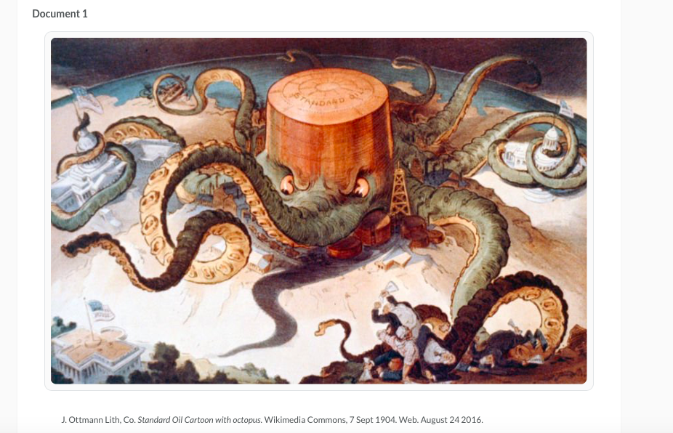

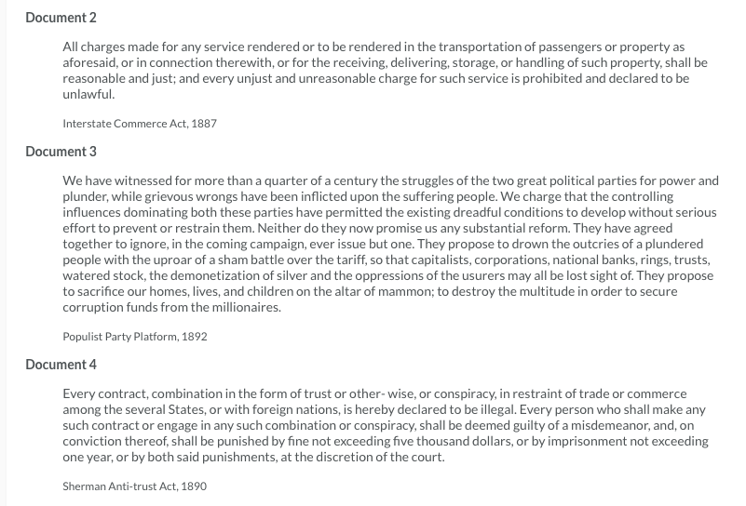
Document 5

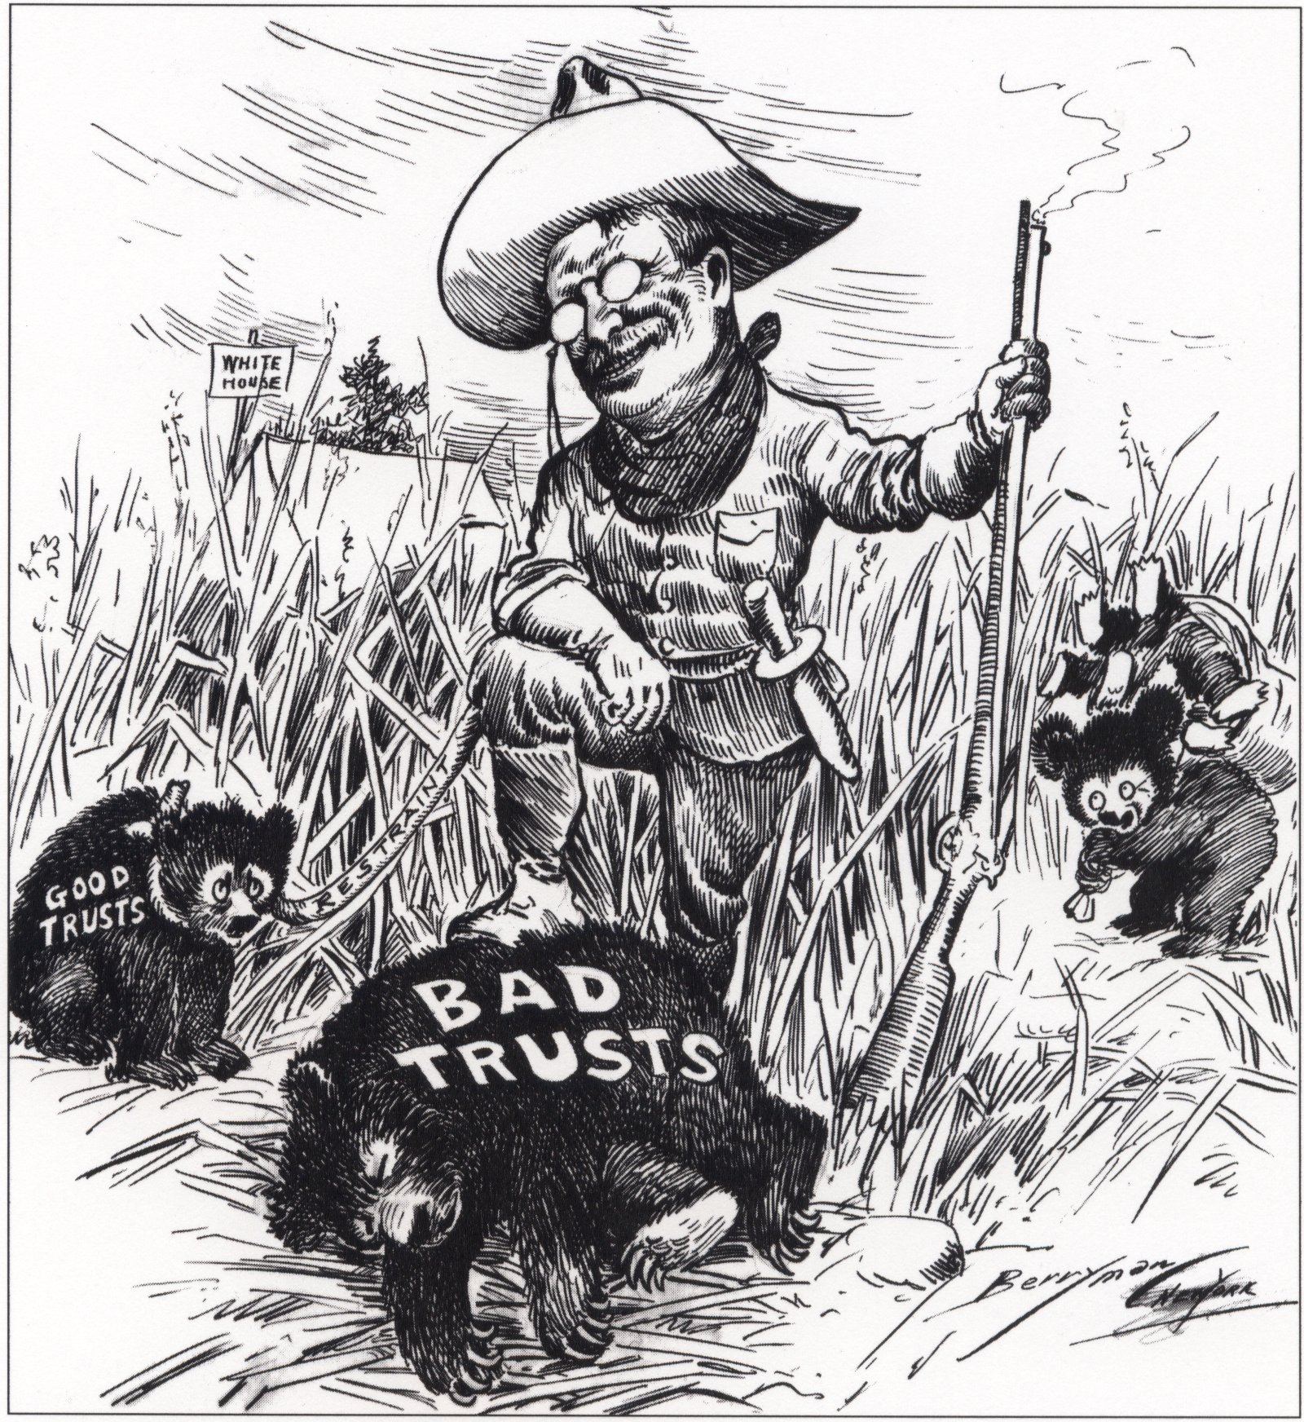
Triumph of the American Nation, Harcourt Brace.

