APUSH DBQ Practice #9
Analyze the ways in which technology, government policy, and economic conditions changed American agriculture in the period 1865-1900. In your answer be sure to evaluate farmers' responses to these changes.
Document A
Agricultural Prices in Dollars per Unit, 1865 - 1900
Source: Historical Statistics of the United States

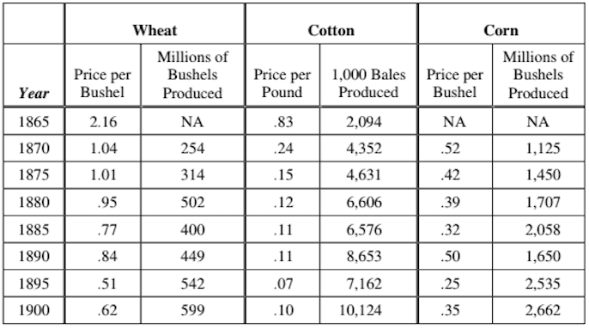

Document B
Source: Prairie Farmer, July 14, 1877.
Our western brothers have accomplished one great good by their war upon the railroads. Some time ago they carried a law through the Illinois legislature, which provides for the limiting of freight rates by a board of officials appointed for this purpose. The railroads, of course, opposed this measure, and it was carried to the United States Supreme Court to test its constitutionality, resulting in a complete victory for the Patrons. Illinois is the only state in the country to have such laws.

Document C
Source: A contract in North Carolina, 1882
To every one applying to rent land upon shares, the following conditions must be read, and agreed to...
The sale of every cropper's part of the cotton to be made by me when and where I choose to sell, and after deducting all they owe me and all sums that I may be responsible for on their accounts, to pay them their half of the net proceeds.
Document D
Source: R. W. McAdams, Oklahoma Magazine, 1894
Many of the country's most profound students of the Indian question — men and women who have made the race and its relation to the nation a life study — have become converts to the policy of individualism and severalty. The citizenship question aside, the folly and injustice of reserving many millions of acres of arable land as a wilderness used only as a camping ground for a few thousand lazy, squalid governmental paupers is palpable. If the Indians must be fed and herded like a dumb brute, it should be done with smaller enclosures and not so senselessly at the expense of the American homesteader.
Document E
Source: Excerpts from a speech by William Jennings Bryan, July 1896
You come to us and tell us that the great cities are in favor of the fold standard. I tell you that the great cities rest upon these broad and fertile prairies. Burn down your cities and leave our farms, and your cities will spring up again as if by magic. But destroy our farms and the grass will grow in the streets of every city in the country.
If they dare to come out in the open field and defend the gold standard as a good thing, we shall fight them to the uttermost, having behind us the producing masses of the nation and the world. Having behind us the commercial interests and the laboring interests and all the toiling masses, we shall answer their demands for a gold standard by saying to them, you shall not press down upon the brow of labor this crown of thorns. you shall not crucify mankind upon a cross of gold.

