APUSH DBQ Practice #4
- Evaluate the extent to which religious ideas of the Second Great Awakening shaped reform movements in the first half of the nineteenth century.
Document 1
Source: Lyman Beecher, “A Reformation of Morals Practicable and Indispensable,” sermon delivered at New Haven, Connecticut, October 27, 1812.
Though reformation be always practicable if a people are disposed to reform, there is a point of degradation from which neither individuals nor nations are disposed to arise, and from which the Most High is seldom disposed to raise them....
To this state of things we are hastening, and, if no effort be made to stop our progress, the sun in his course is not more resistless than our doom. Our vices are digging the grave of our liberties, and preparing to entomb our glory....
Traveling, and worldly labor, and visiting, and amusement on the Sabbath, will neither produce nor preserve such a state of society, as the conscientious observance of the Sabbath has helped to produce and preserve.
The enormous consumption of ardent spirits in our land will produce neither bodies nor minds like those which were the offspring of temperance and virtue.
The neglect of family government, and family prayer, and the religious education of children, will not produce such freemen as were formed by early habits of subordination, and the constant influence of the fear of God. . . .
The missionary spirit, which is beginning to pervade our land, promises also, an auspicious reforming influence.

Document 2
Source: “The drunkard’s progress, or the direct road to poverty, wretchedness & ruin,” designed and published by John Warner Barber, 1826.

(see next page)
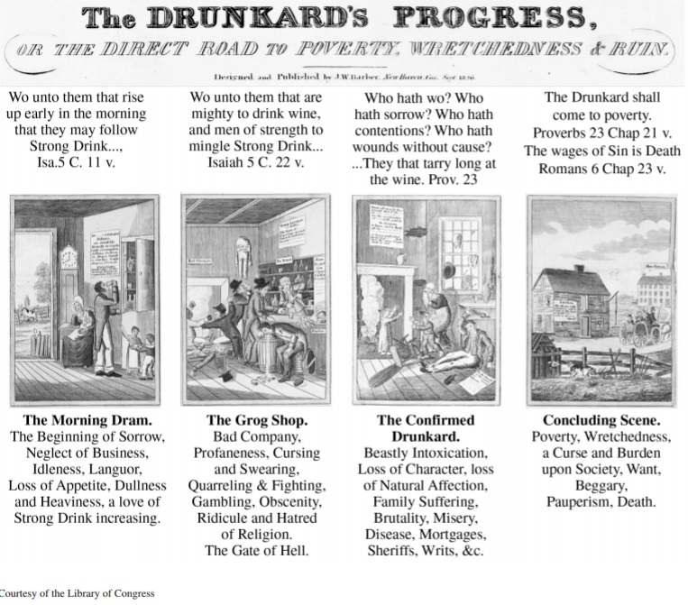
Document 3
Source: Charles Grandison Finney, “What A Revival of Religion Is,” New York Evangelist, 1834.

Christians will have their faith renewed.... When they enter into a revival, they no longer see men as trees walking, but they see things in that strong light which will renew the love of God in their hearts. This will lead them to labor zealously to bring others to him. They will feel grieved that others do not love God, when they love him so much. And they will set themselves feelingly to persuade their neighbors to give him their hearts. So their love to men will be renewed. . . . They will have a longing desire for the salvation of the whole world. They will be in agony for individuals whom they want to have saved; their friends, relations, enemies....
A revival breaks the power of the world and of sin over Christians. It brings them to such vantage ground that they get a fresh impulse towards heaven. They have a new foretaste of heaven, and new desires after union to God; and the charm of the world is broken, and the power of sin overcome.The worst part of human society are softened and reclaimed, and made to appear as lovely specimens of the beauty of holiness.
Document 4
Source: Unitarian minister George Ripley writing about his planned utopian community, Brook Farm, in a letter to Ralph Waldo Emerson, 1840.
Our conversation in Concord was of such a general nature, that I do not feel as if you were in complete possession of the idea of the Association which I wish to see established.
Our objects, as you know, are to insure a more natural union between intellectual and manual labor than now exists; to combine the thinker and the worker, as far as possible, in the same individual; to guarantee the highest mental freedom, by providing all with labor, adapted to their tastes and talents, and securing to them the fruits of their industry; to do away the necessity of menial services, by opening the benefits of education and the profits of labor to all; and thus to prepare a society of liberal, intelligent, and cultivated persons, whose relations with each other would permit a more simple and wholesome life, than can be led amidst the pressure of our competitive institutions.
To accomplish these objects, we propose to take a small tract of land, which, under skillful husbandry, uniting the garden and the farm, will be adequate to the subsistence of the families; and to connect with this a school or college, in which the most complete instruction shall be given, from the first rudiments to the highest culture. Our farm would be a place for improving the race of men that lived on it; thought would preside over the operations of labor, and labor would contribute to the expansion of thought; we should have industry without drudgery, and true equality without its vulgarity.
Document 5
Source: Dorothea Dix, “Remarks on Prisons and Prison Discipline in the United States,” 1845.
I would not have officers become preachers; I would not have them much interfere with the religious teaching, so called, of the prisoners; but I would have them all moral guides. . . . In order to do good, a man must be good; and he will not be good except he have instruction by counsel and by example. Now who have the power of exercising these direct hourly influences, except the officers who have charge of the prisons and of the prisoners? It is the word in season, and fitly spoken, which may kindle a desire in the degraded to retrieve himself. The faint desire becomes quickened into a living purpose; this passes into the fixed resolve; and this creates a sentiment of self-respect. Self-respect implanted, conducts to the desire of possessing the respect and confidence of others; and through these paths grow up moral sentiments, gradually increasing and gaining strength; and, in time, there is the more profound and soul-saving sentiment of reverence for God, acknowledgment of his laws, and a truer perception of that sanctifying knowledge which causeth not to err.

