APUSH DBQ Practice #10

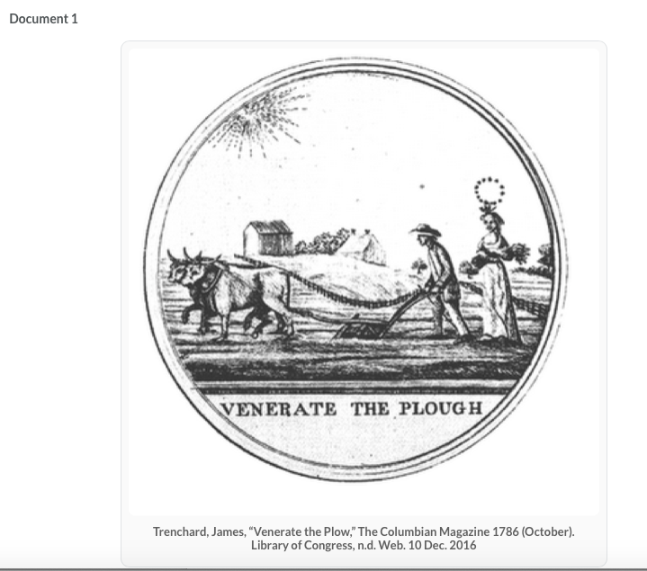

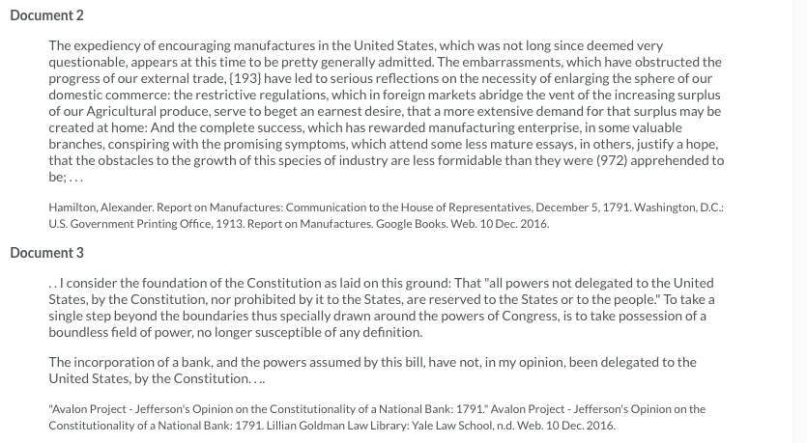

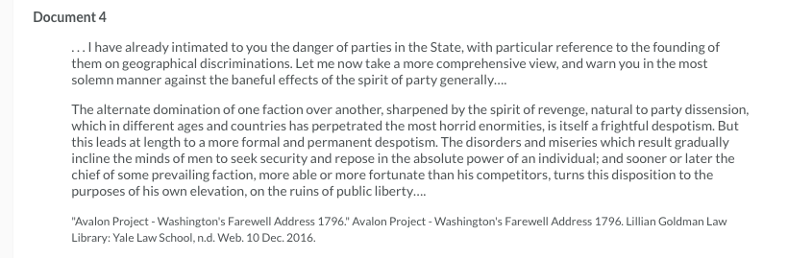

DOC 5. Founding Fatherfest Political Cartoon – Thomas Jefferson, 1801.
